Tuong Chu

tuong.chu@sjsu.edu

Abstract

This is a Google Search Engine Simulator. In this program, the user will be able to search for a keyword and perform different operations on the search results.

[pROgramming assignment 3]

CS146-S7

Contents

Specification 2

Design 2

Running Instruction 3

Implementation 4

Main.java 5

RBTree.java 7

Spider.java 15

PageRank.java 17

SpiderLeg.java 20

Test Case 1 22

Test Case 2 26

Test Case 3 28

Test Case 4 33

Test Case 5 39

# Specification

This program assignment aims to make a search engine that is similar to Google which finds the information you need when you browse the Web. Like Google, this program will use sorting algorithm, indexing, searching, and priority queueing techniques to generate search results.

This program will use an automated program called spiders or crawlers which are used to find keywords on the websites. More importantly, it will rank its search results based on a trademarked algorithm called PageRank, which assigns each Web page a relevancy score.

A web page’s PageRank depends on four factors: the frequency of keywords within the Web page, how long the Web page has existed, the number of other Web pages that link to the page, and how much the webpage owner has paid for advertisement purpose.

For this programming assignment, the program must implement five major features:

1. Build up a Red-Black Tree with 30 URLs retrieved from the web crawler
2. Allow users to insert any URL to the RB Tree based on its total score.
3. Allow users to search a URL by entering a PageRank or total score
4. Allow users to delete any URL from the URL RB Tree by entering a PageRank or total score
5. Allow users to make a sorted list of URLs based on the total score

# Design

In terms of user interface:

The user can choose one from the 5 options on the terminal:

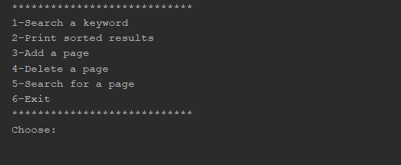

1. Search a keyword: search for a keyword, retrieve a list of 30 URLS based on the keyword, and print the list.
2. Print sorted results: print sorted list of 30 URLS in a decreasing order, from URL with biggest score to URL with smallest score. Each must show index, total score, PageRank, color, and URL.
3. Add a page: Ask the user to enter a new URL and its score they want to add, then add the URL to the list.
4. Delete a page: Ask the user to enter a PageRank number of a page they want to delete, then delete the URL from the list.
5. Search for a page: Ask the user to enter a PageRank number of a page they want to search in the list. Print index, total score, PageRank, color, and URL of that page.

In terms of data structure:

1. After getting 30 Web pages from the web crawler, each Web page will be stored in a PageRank object. Such object will contain all the attributes of that Web page such as URL, total score, color, index, etc. Additionally, each PageRank object will also has a left child, right child, and parent that point to null.
2. All PageRank objects will be inserted into a RBTree object, which is created by class RBTree. The RBTree object will contain two private members which are **PageRank root** and **PageRank nil**. When a RBTree object is first called, it means that the tree is empty so **root** = **nil**, while all of nil’s values are 0 except its color which is always black.
3. Each time a new PageRank object is added into the RBTree object, the newly added PageRank object is always red and it has **nil** as its children. If the newly added object violates the Red-Black Tree’s properties, the tree will automatically recolor or restructure.
4. If a PageRank object is deleted from the tree and it results in a violation of the Red-Black Tree’s properties, the tree will also automatically recolor or restructure.
5. After the tree is balanced and properly colored, we can set the PageRank number for each PageRank object by walking the tree from object with biggest score to object with smallest score. After that, if we print the sorted list, the PageRank numbers will be there.
6. If the user wants to search for a specific page from the search results, the program will ask for the PageRank number of the page they want to search. To know the PageRank number of a specific page, the user just needs to check the sorted search results.

# Running Instruction

Run the program with file .jar:

* Extract folder Tuong_Chu_PA3 from Tuong_Chu_PA3.zip to anywhere you like
* Open the folder
* Copy the path of the gs3.jar file. In cmd, type: java -jar then paste the path you just copied.
* The path depends on where you put the gs.jar file. For example: "java -jar C:\Users\kumaq\←- Documents\Tuong_Chu_PA3\gs3.jar"

# Implementation

There are 5 different files for the program:

**Main.java**

* static void Search (RBTree T)
* static int Options ()
* static void main (String[] args)

**PageRank.java**

* PageRank ()
* void setOriginColor (String s)
* String getOriginColor ()
* void setURL (String s)
* void setRandomScore ()
* void setIndex (int i)
* void setRank (int i)
* int getRank ()
* int getScore ()
* void setFactors (List< Integer > f)
* String getColor ()
* void setColor (String s)
* PageRank getLeft ()
* PageRank getRight ()
* PageRank getParent ()
* void setLeft (PageRank z)
* void setRight (PageRank z)
* void setParent (PageRank z)

**RBTree.java**

* RBTree ()
* PageRank Tree_Miminum (PageRank x)
* void Left_Rotate (PageRank x)
* void Right_Rotate (PageRank x)
* void RB_Insert_FixUp (PageRank z)
* void RB_Insert (PageRank z)
* void PrintTree ()
* void Inorder_Tree_Walk (PageRank x)
* boolean isEmpty ()
* PageRank Tree_Search (PageRank root, int k)
* void SearchPage ()
* void RB_Transplant (PageRank u, PageRank v)
* void RB_Delete_FixUp (PageRank x)
* void RB_Delete (PageRank z)
* void AddPage ()
* void DeletePage ()

**Spider.java**

* void search (String url, String searchWord, RBTree T)

**SpiderLeg.java** Used by Spider.java

* boolean crawl (String url)
* boolean searchForWord (String searchWord)
* List< String > getLinks ()

## Main.java

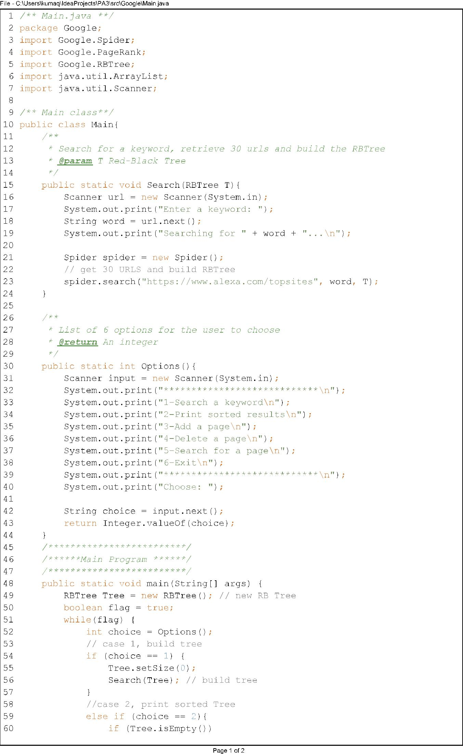

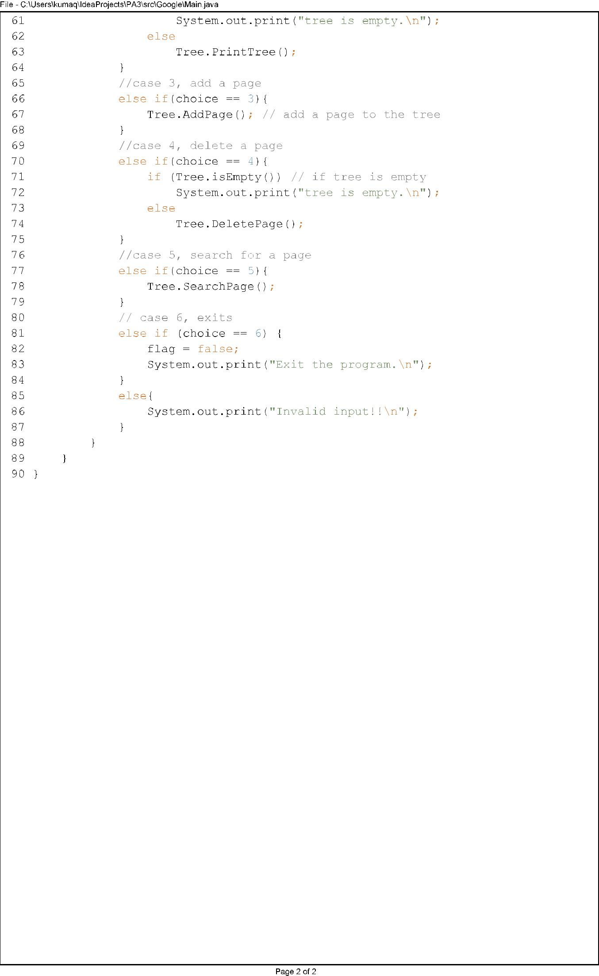

## RBTree.java

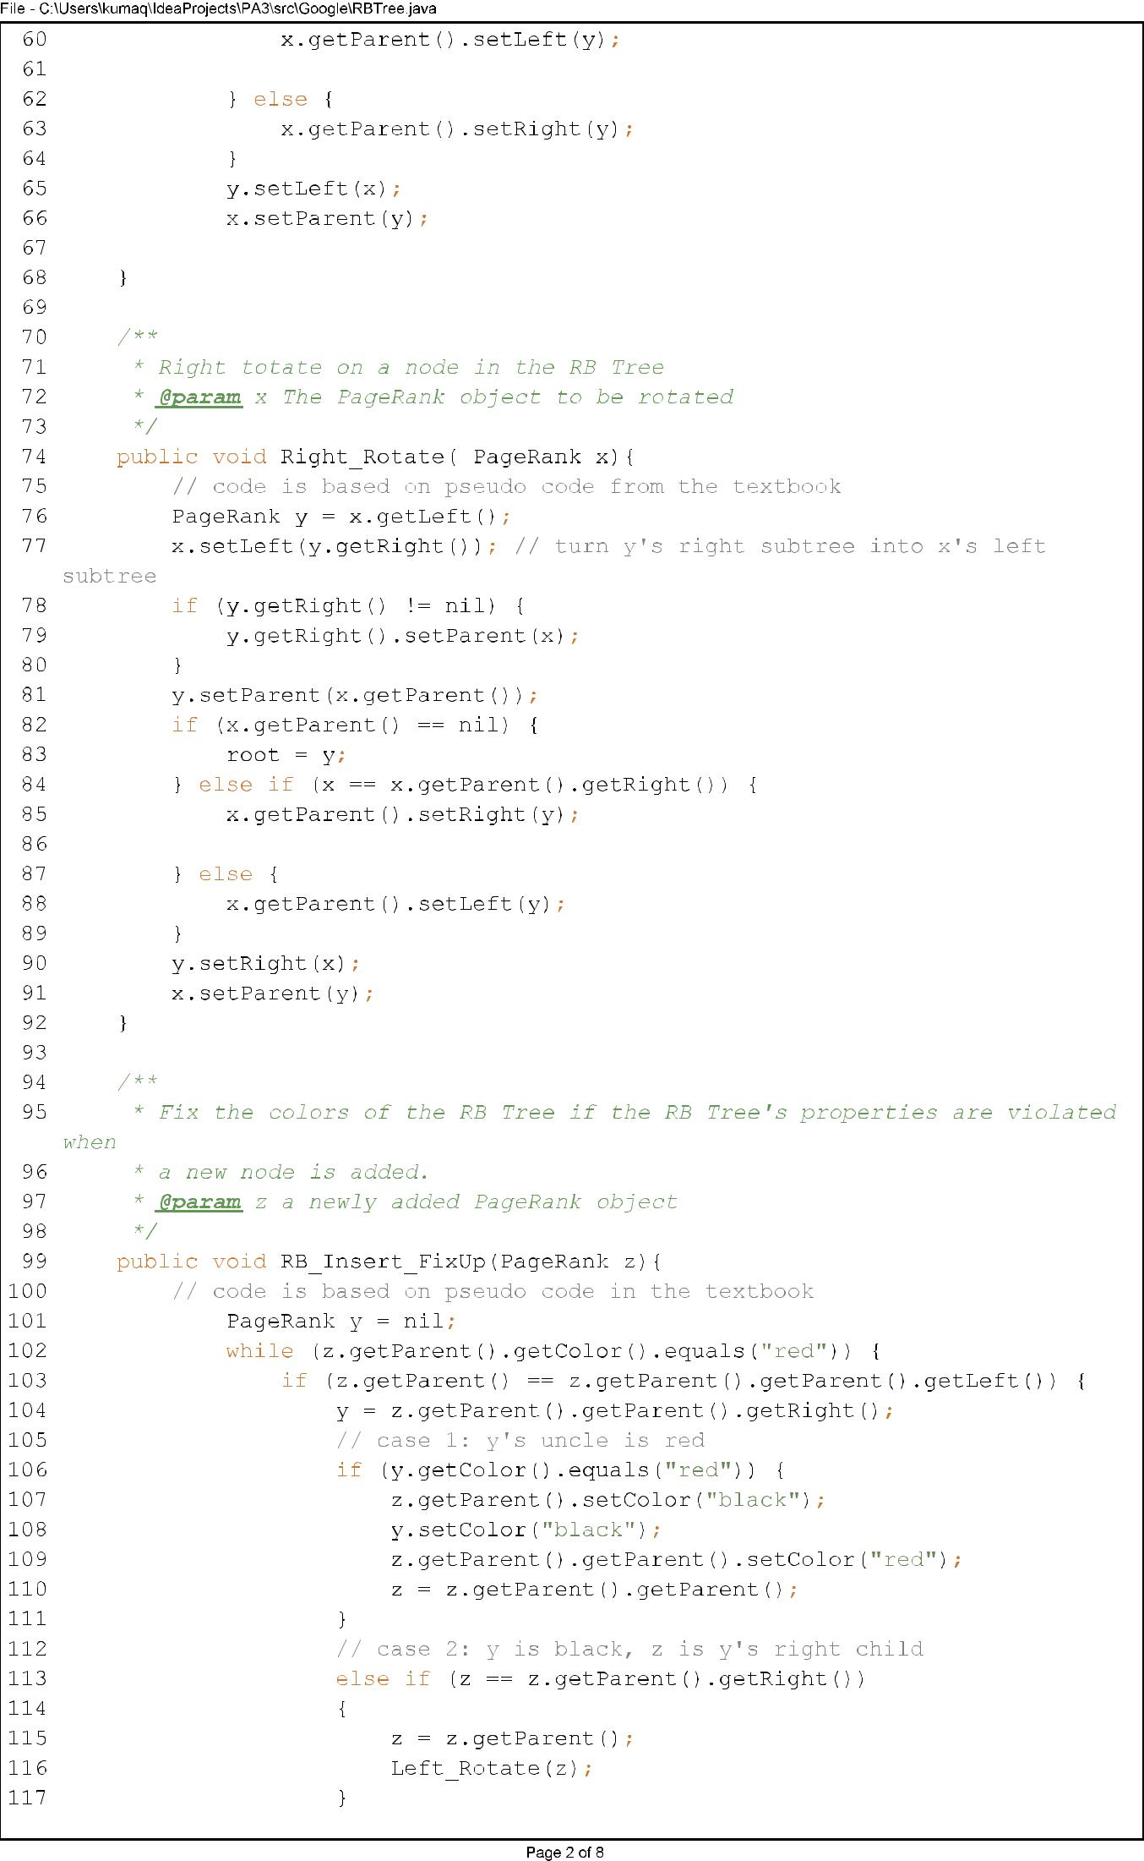

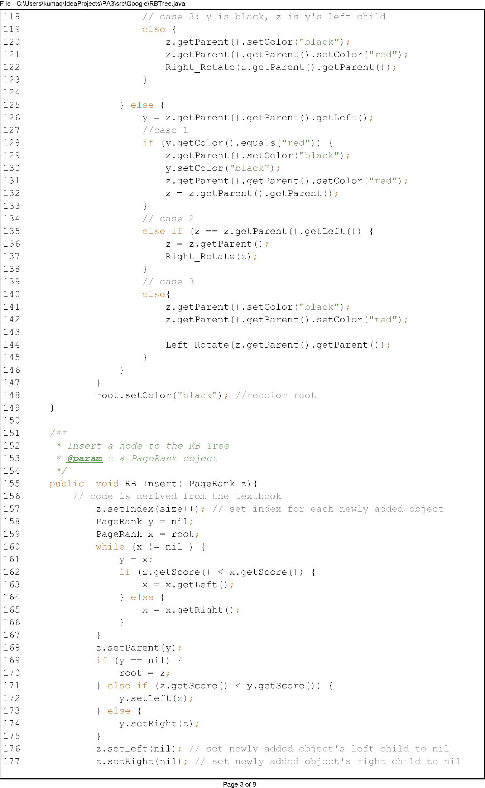

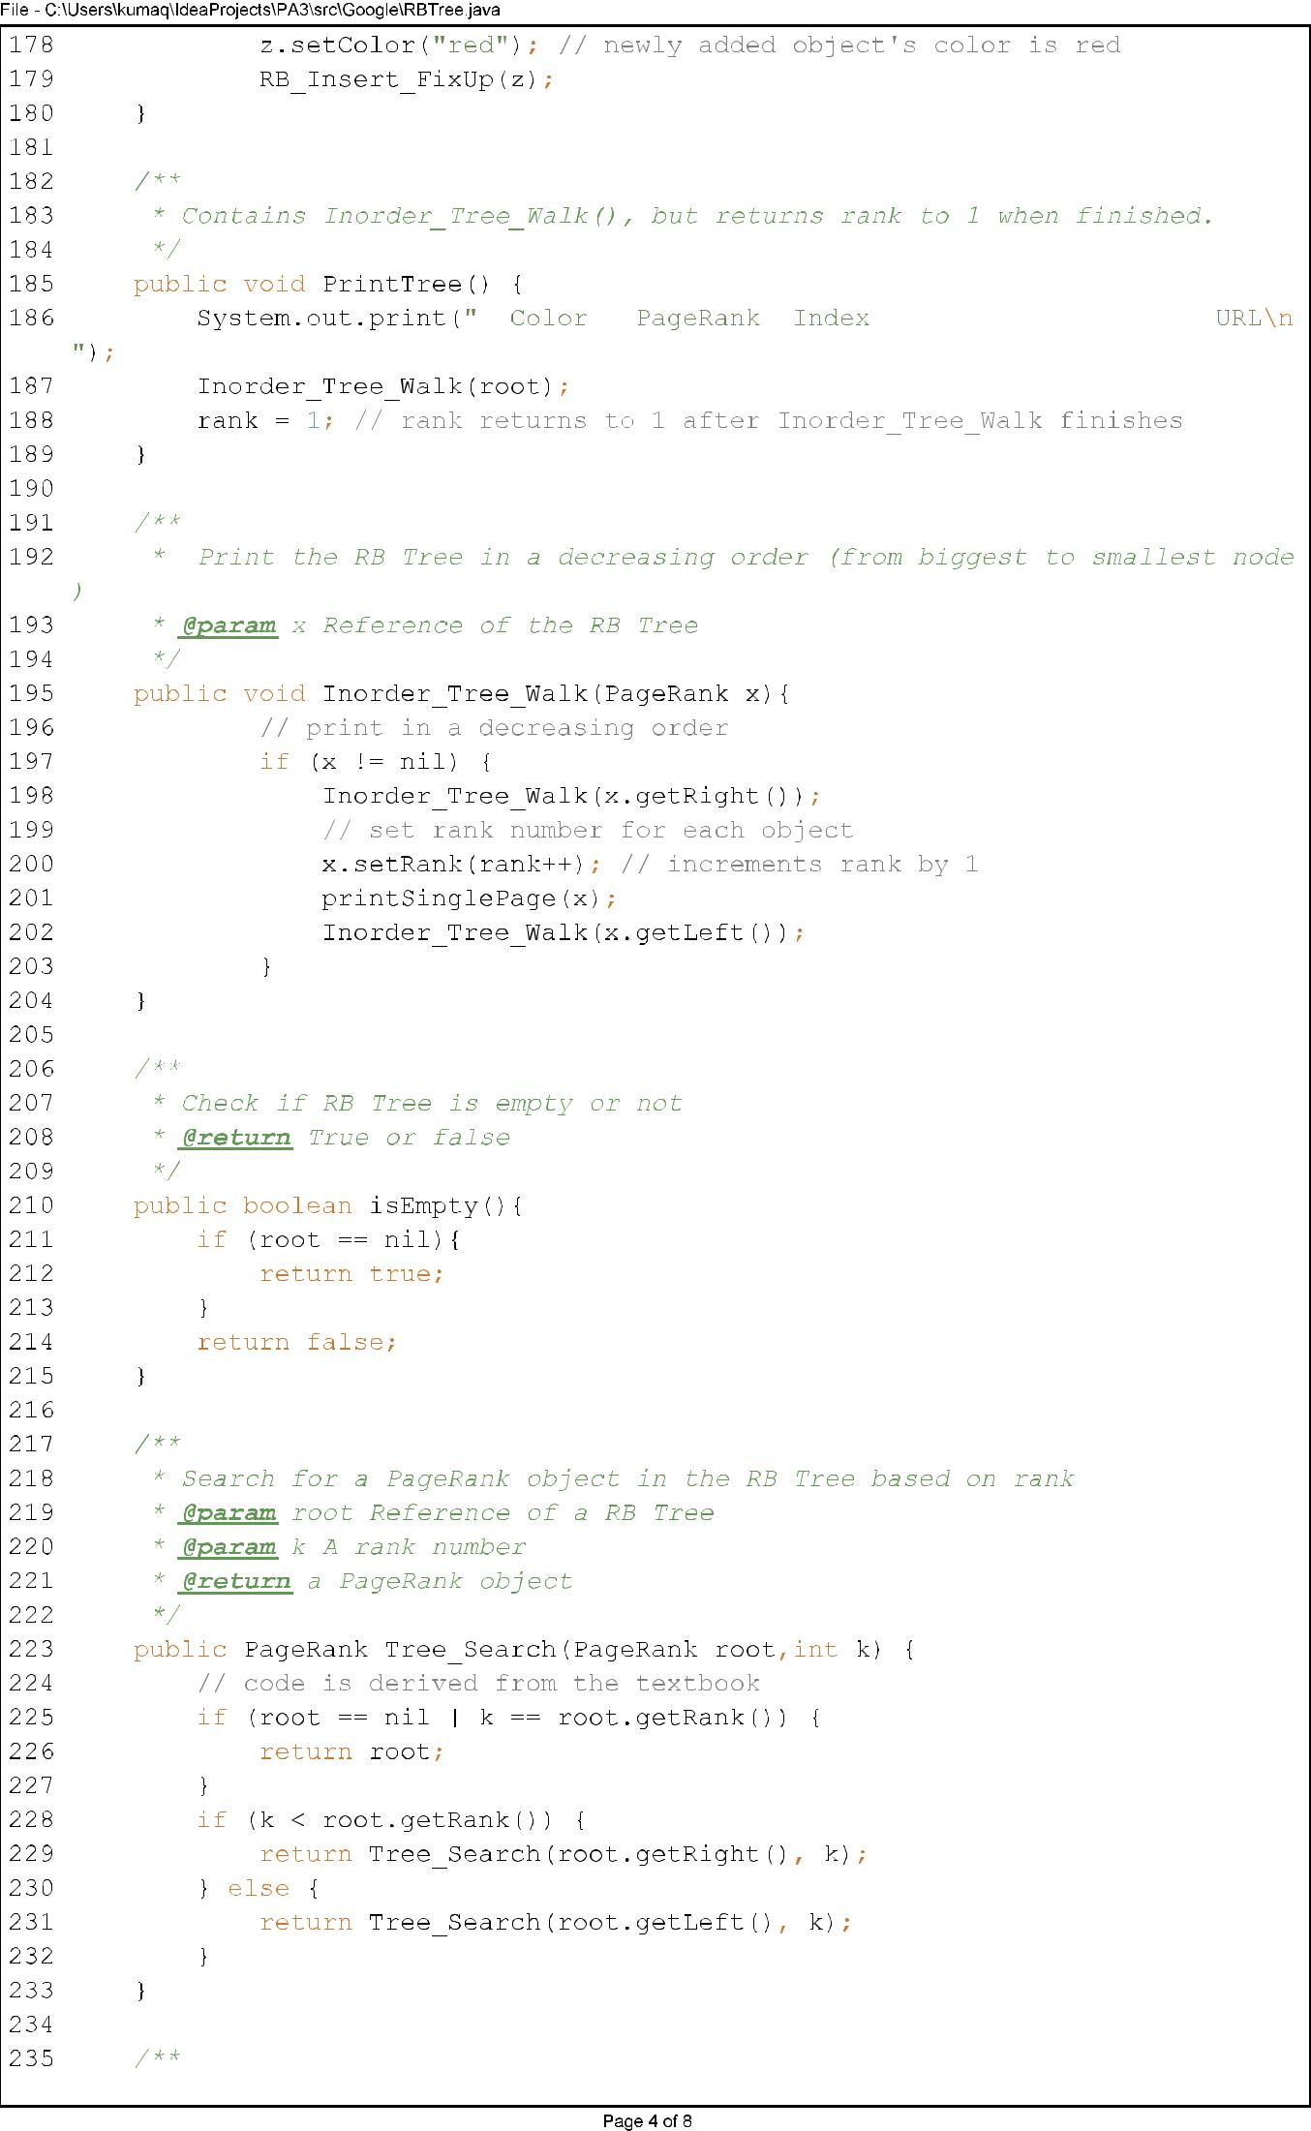

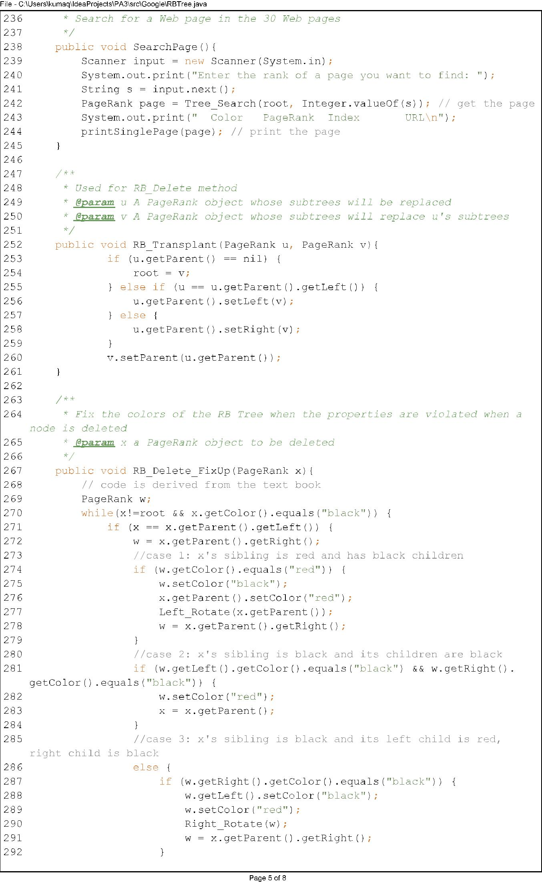

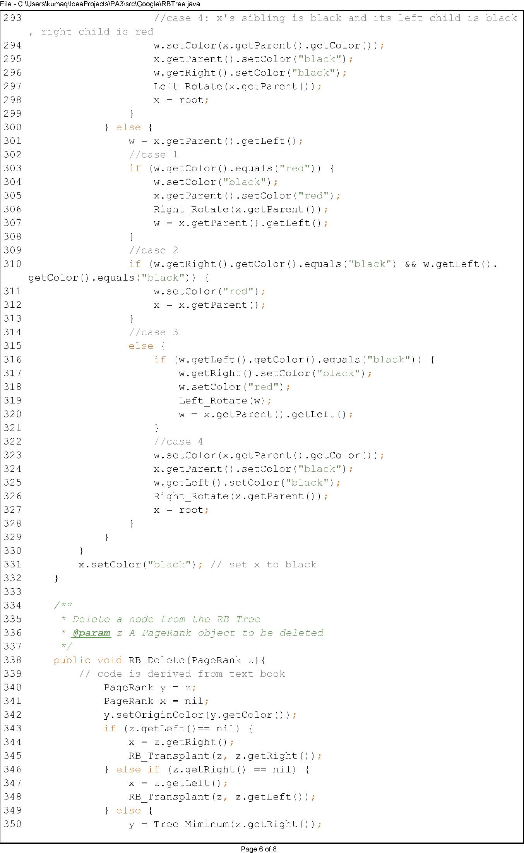

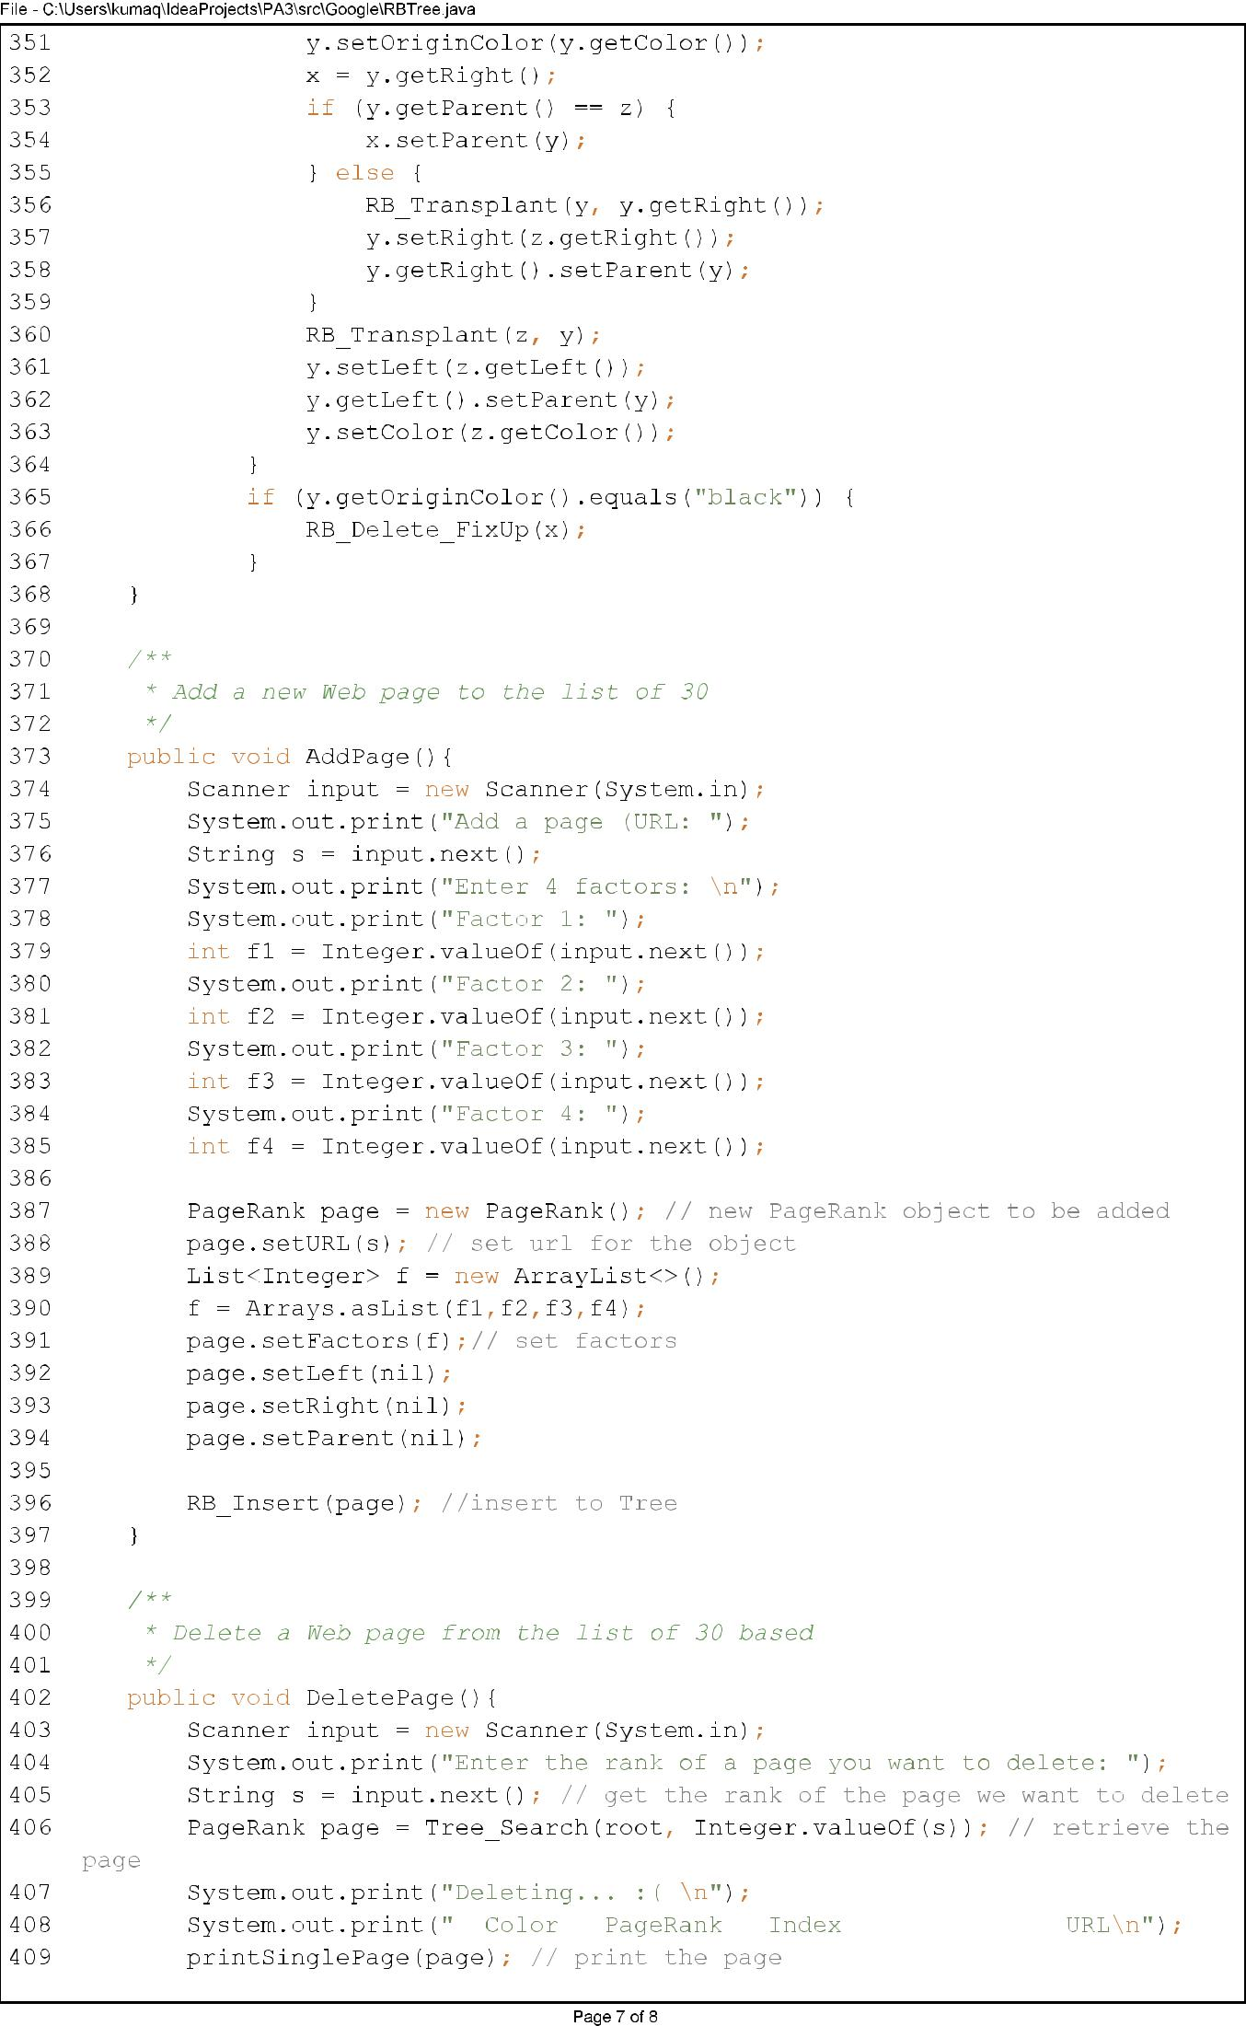

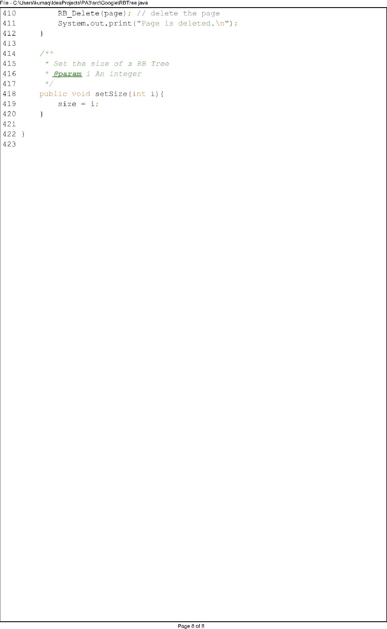

## Spider.java

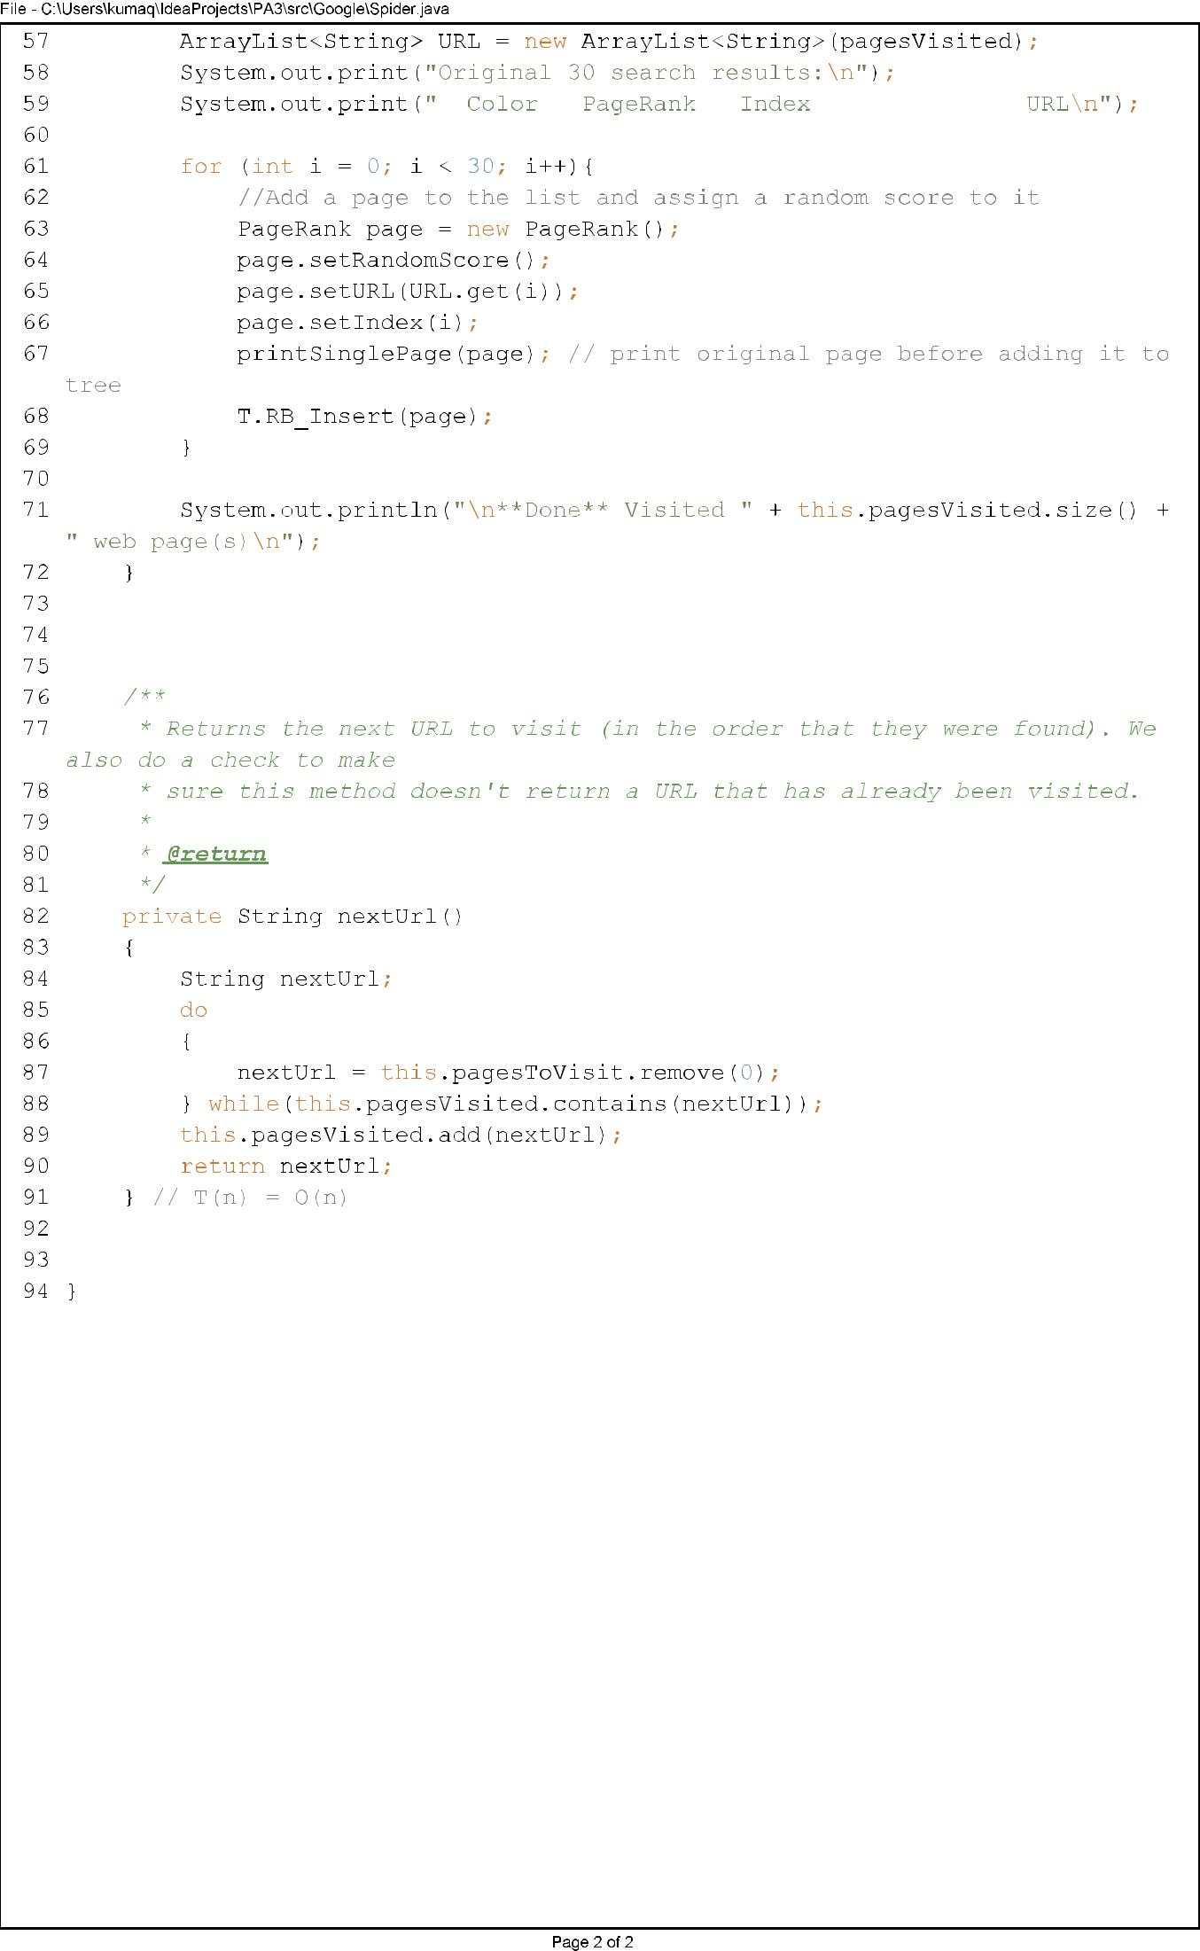

## PageRank.java

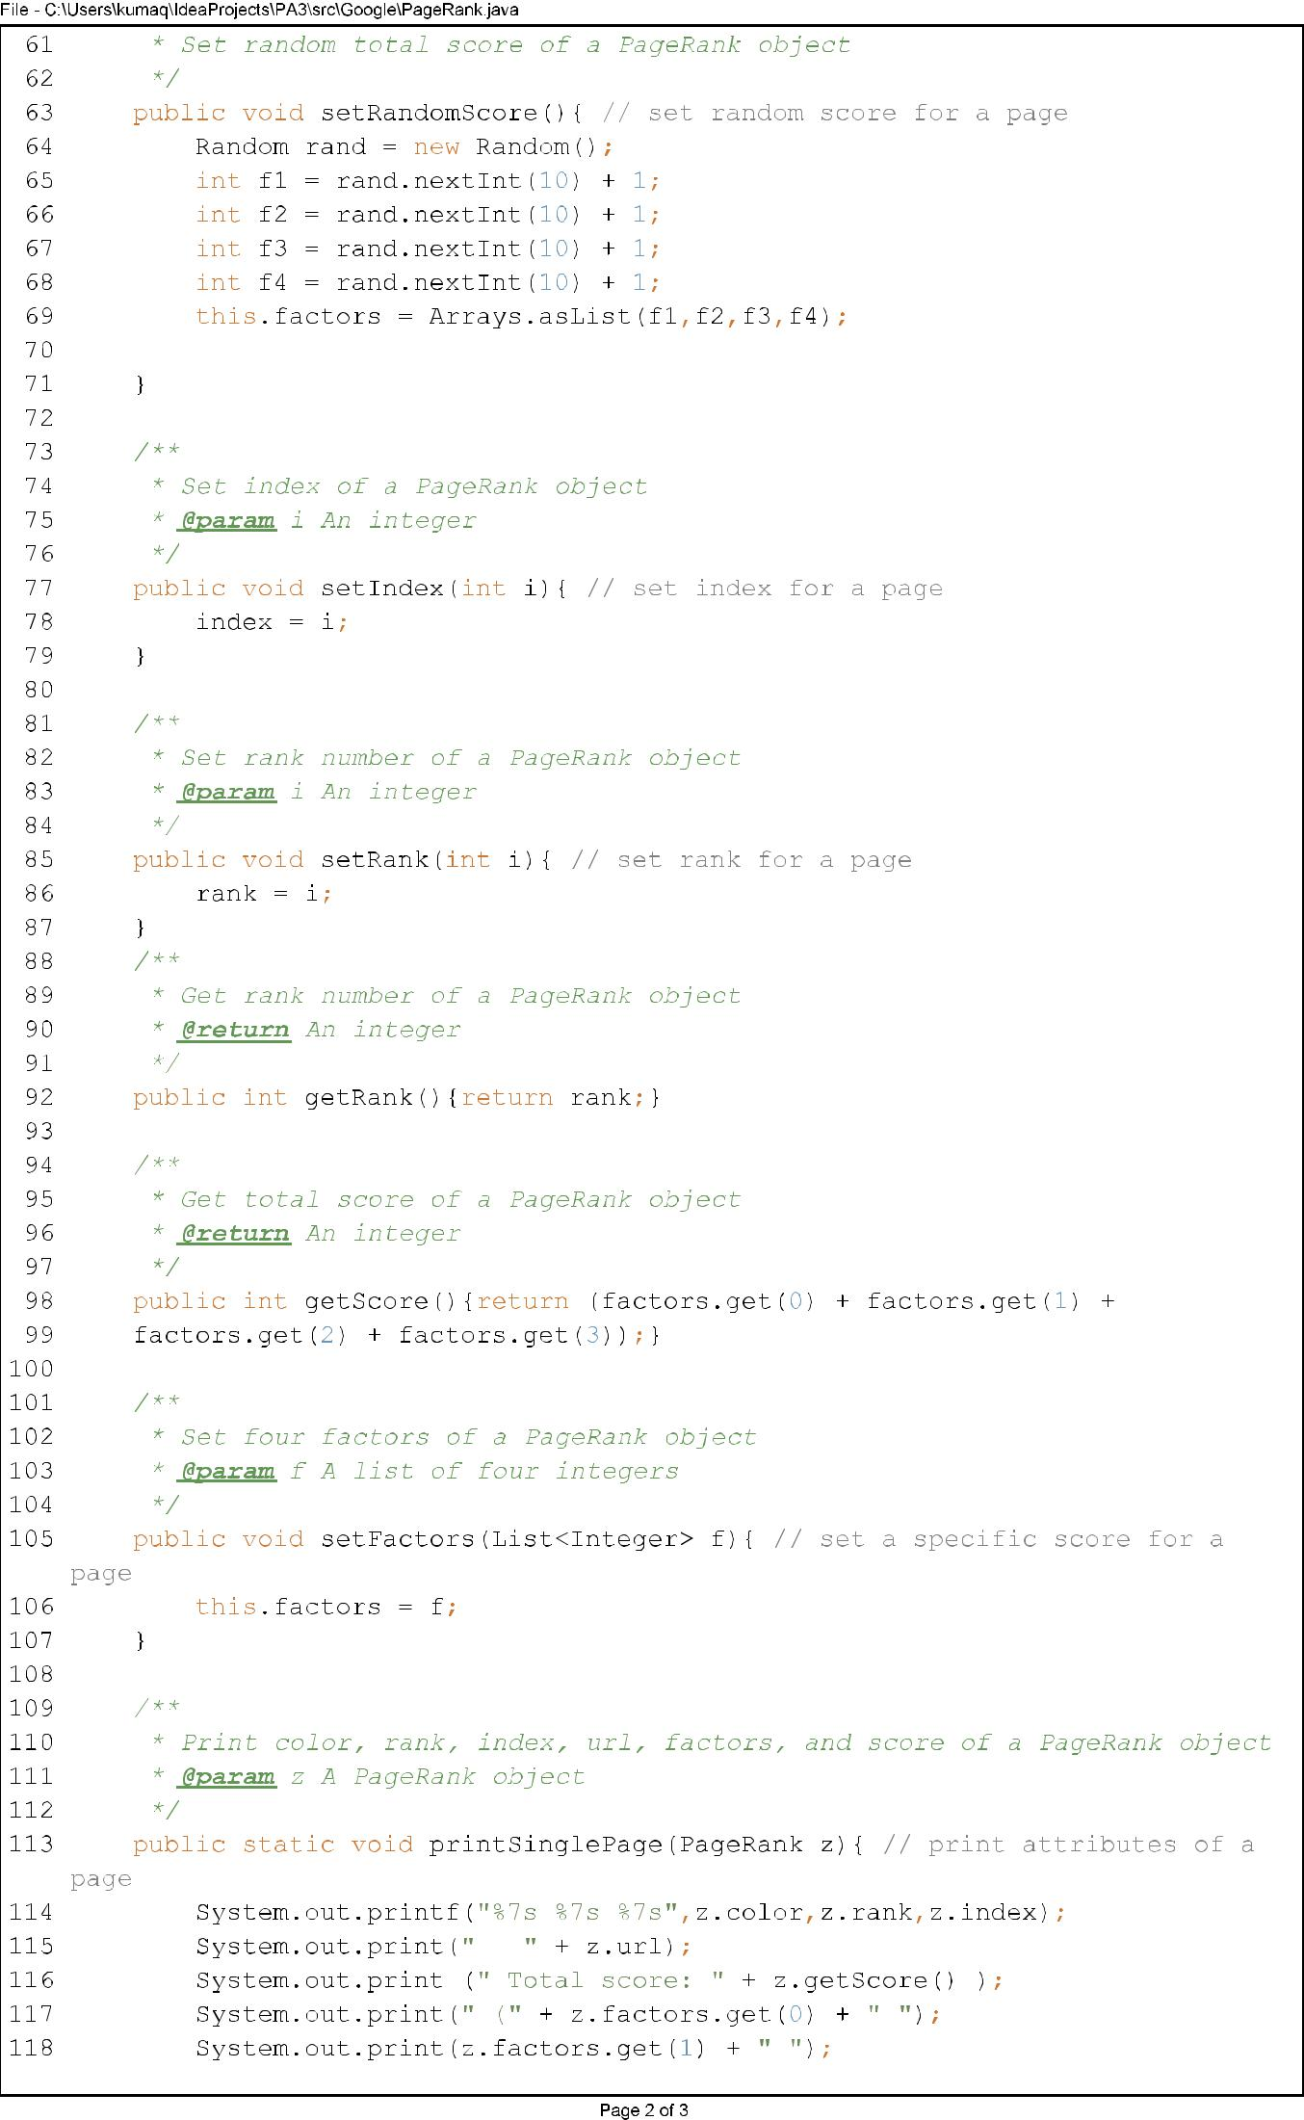

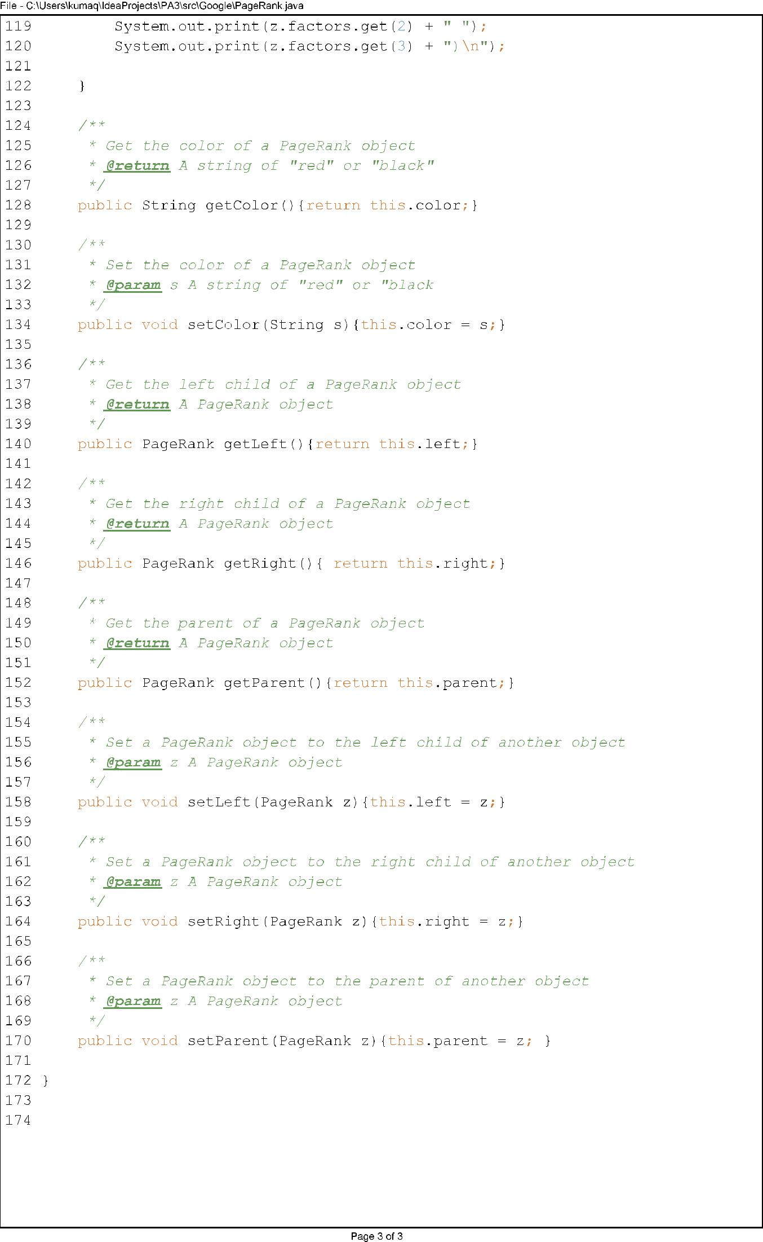

## SpiderLeg.java

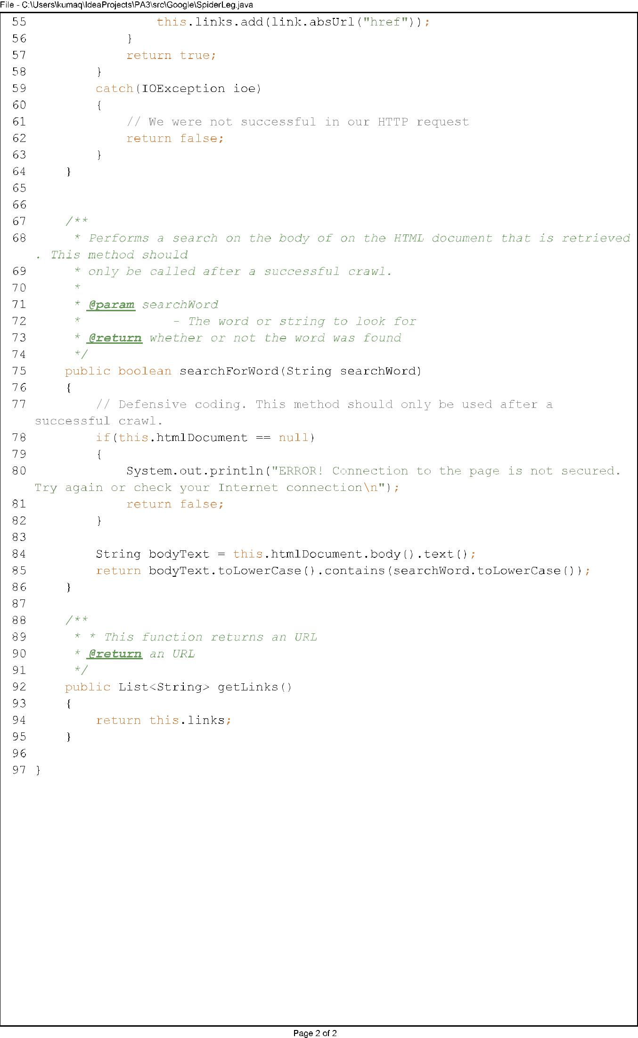

# Test Case 1

In this test case, I will search for a keyword and print the sorted search results:

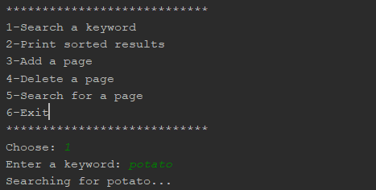

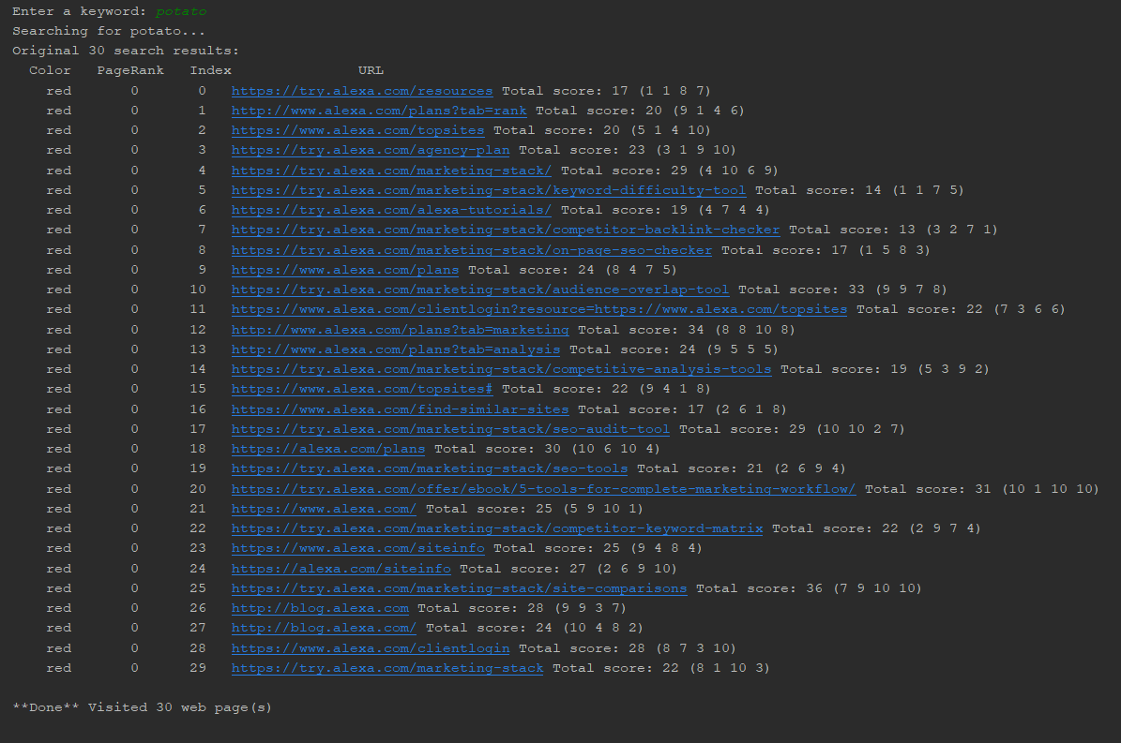

After searching for ‘potato’, the program displays 30 search results. All of them are red and each has a random total score. Each is assigned an index number based on the order it was inserted to the Red-Black Tree. Therefore, the URL with index 0 was the first URL to be found and inserted into the Red-Black Tree, and the URL with index 29 was the last one to be inserted. Since the list is not sorted yet, the PageRank number is 0 for all of them.

Next, I will show the sorted results:

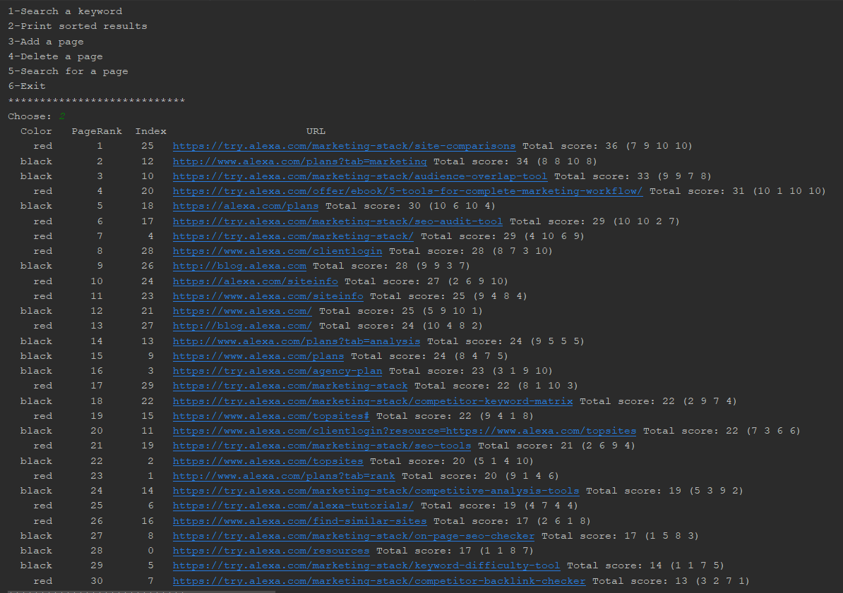

After all URLs have been inserted into the Red-Black Tree with RB_Insert method, each node in the Tree is colored either red or black by the RB_Insert_Fixup method. Each node is inserted carefully so that the Tree maintains its BST properties. After that, Inorder_Tre_Walk method will walk the entire Red-Black Tree and print the URLS, from biggest total score to smallest total score.

Therefore, the URL with the biggest total score is the node on the far right of the Tree, while the URL with the smallest score is on the far left. As the list is being sorted, PageRank number will be assigned to each URL by the Inorder_Tree_Walk method.

A hand-drawn picture of the Red-Black Tree after insertion:

Let’s search for another keyword:

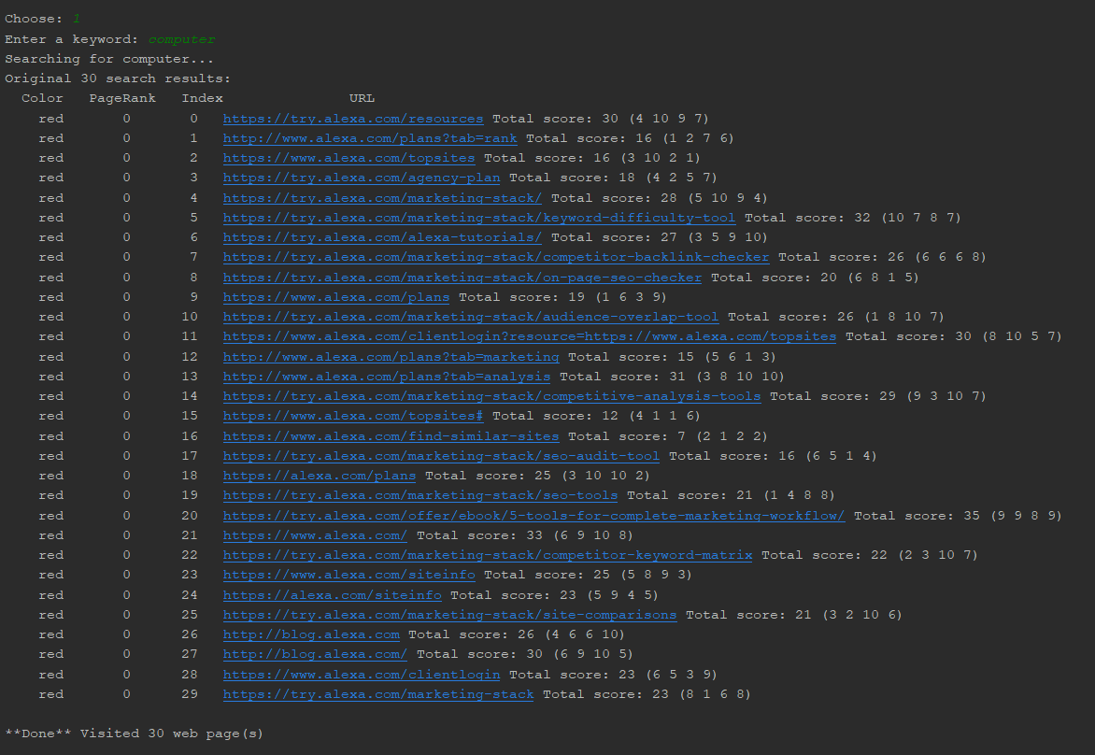

Print sorted results for keyword ‘computer’:

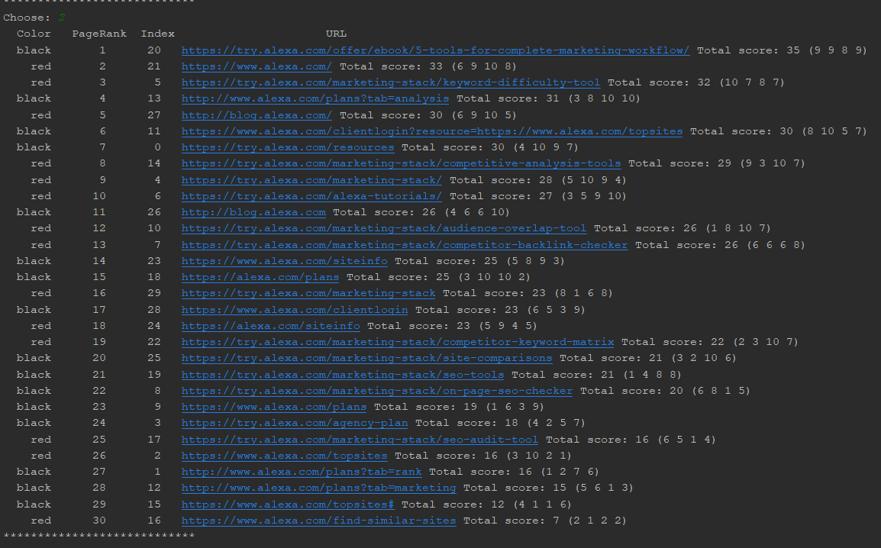

The list is sorted perfectly and colors are correct. RB_Insert, RB_Insert_Fixup, and Inorder_Tree_Walk are working correctly.

Here is a hand-drawn tree of the result:

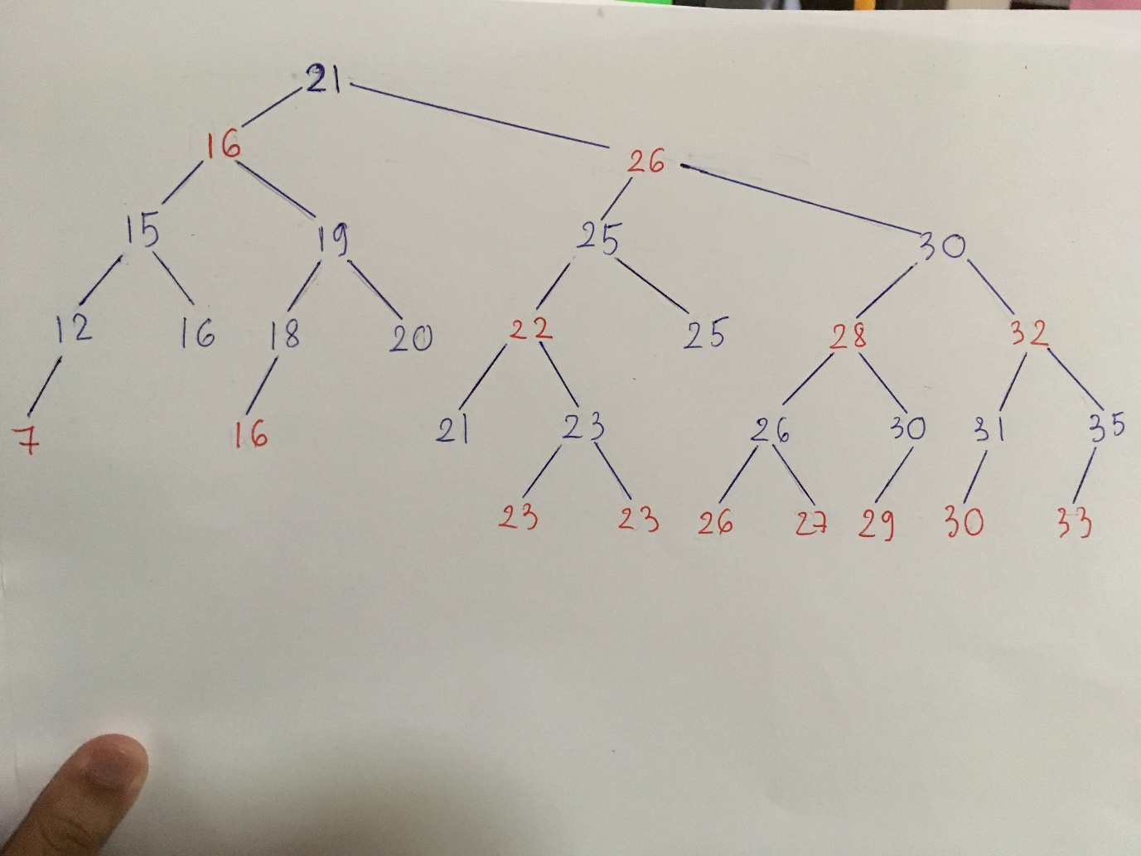

# Test Case 2

In this test case, I will search for a specific URL from the search results of ‘computer’ in Test Case 1:

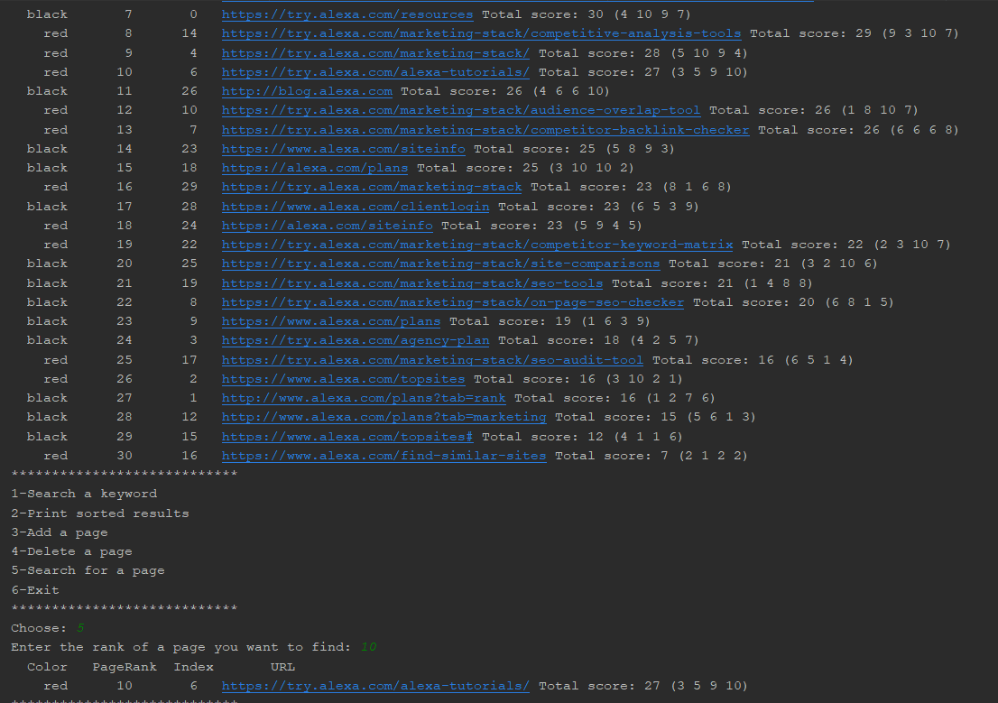

To search for a specific page, I will enter a PageRank number that I saw from the sorted list of search results. Here, I choose PageRank 10, and the program correctly retrieves the page I want to find with the exact same color, PageRank, index, URL, and total score.

Let’s find another page:

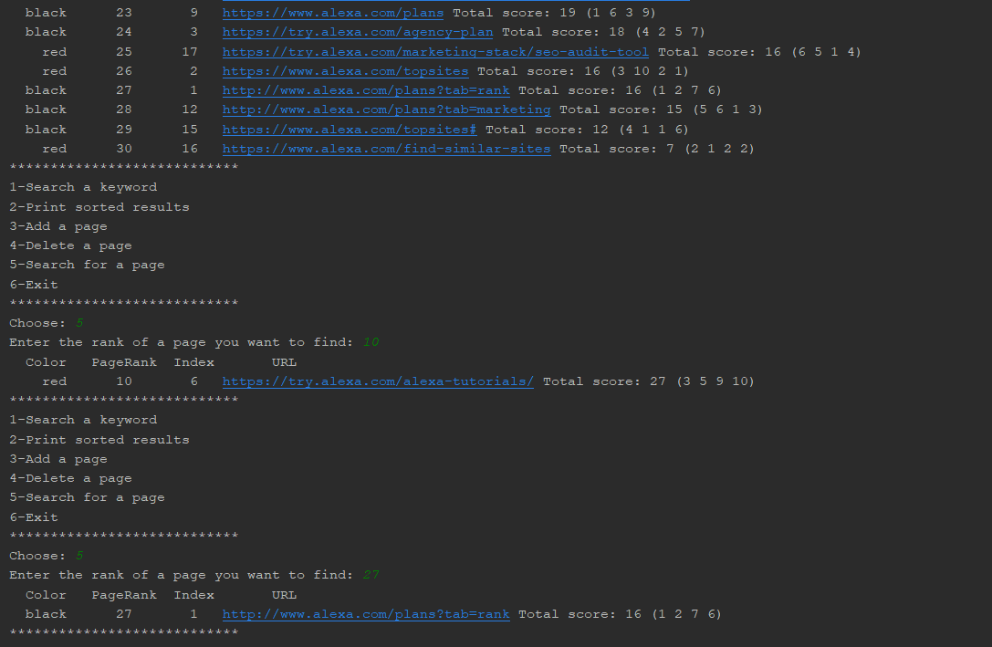

I enter PageRank 27 and the program retrieves the exact page I want to find. This means that Tree_Search method is working properly.

# Test Case 3

In this test case, I will test RB_Insertion, RB_Insertion_Fixup, Left_Rotate, and Right_Rotate.

I will continue with the search results of ‘computer’ from Test Case 1, but this time, I will add a new URL to the list:

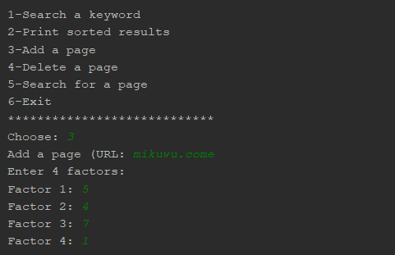

Next, I will check the list if the new URL has been added and sorted:

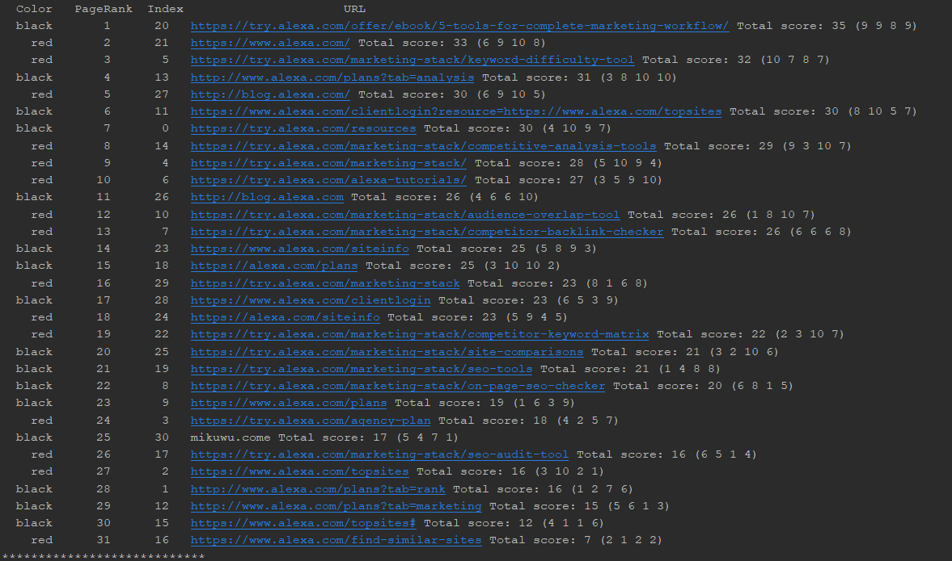

As you can see, the new URL has been added to the Red-Black Tree. Normally, a new node being added will have a red color. However, the newly added node violates the properties of the Tree, so RB_Insert_Fixup recolors it as well as restructuring the tree.

The newly added URL falls into case 2 of insertion because it is the right child, its parent is red, and its uncle is black. Therefore, the program performs two rotations with the use of Left_Rotation and Right_Rotation, and recolor nodes that are involved.

A hand-drawn picture after case 2 insertion:

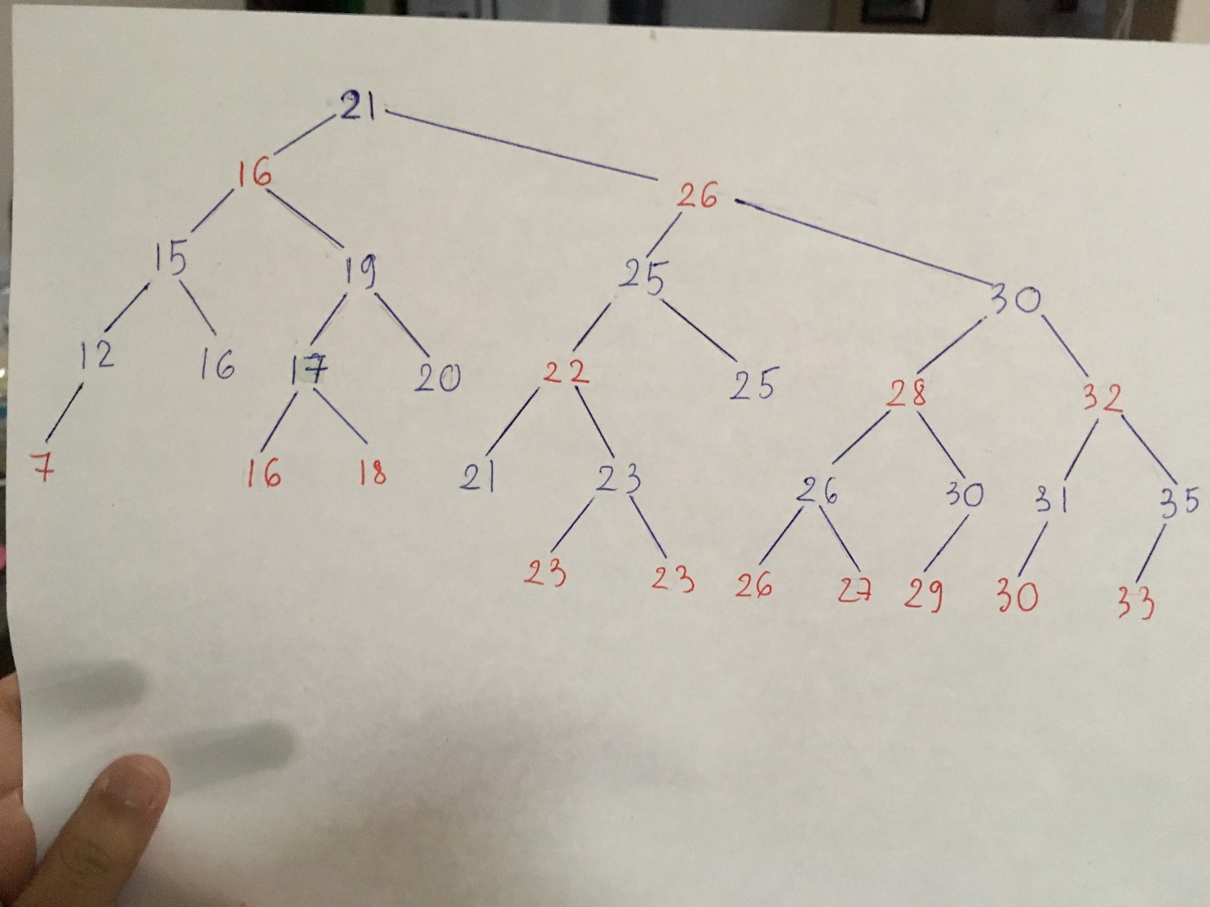

That was case 2 of insertion, now I will try to do case 1: the newly added node is a red child, its parents is red, and its uncle is red. Therefore, I will add an URL with a total score of 22:

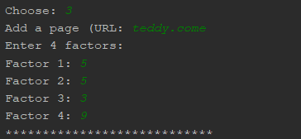

Sorted results:

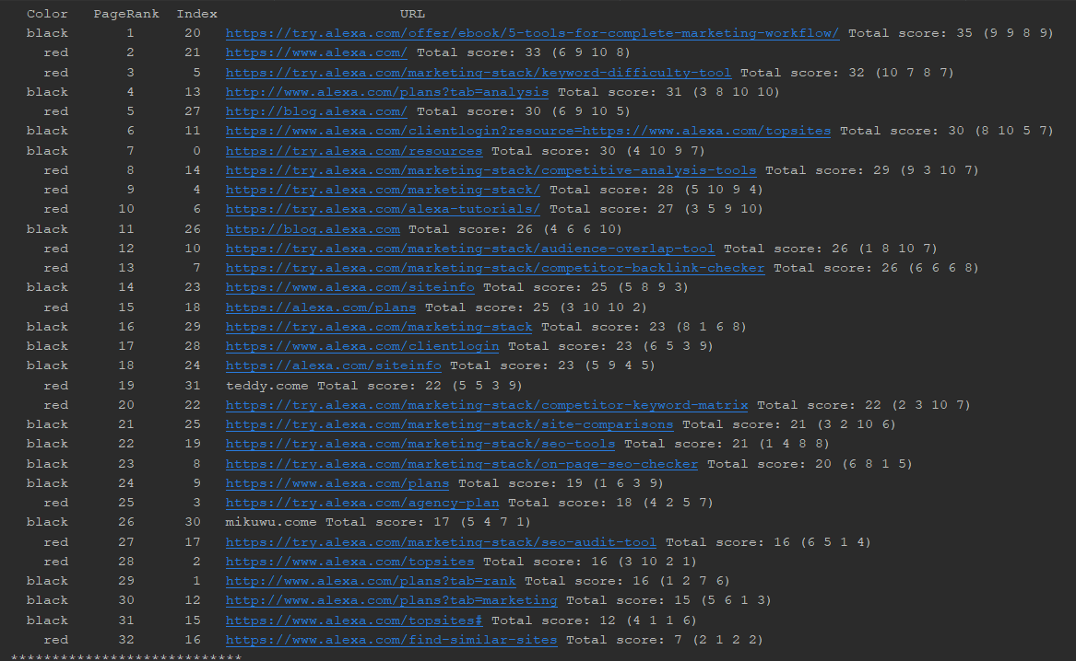

The new URL is added as expected with a color of red. The tree is also sorted, recolored and restructured.

A hand-drawn picture of the tree after case 1 insertion:

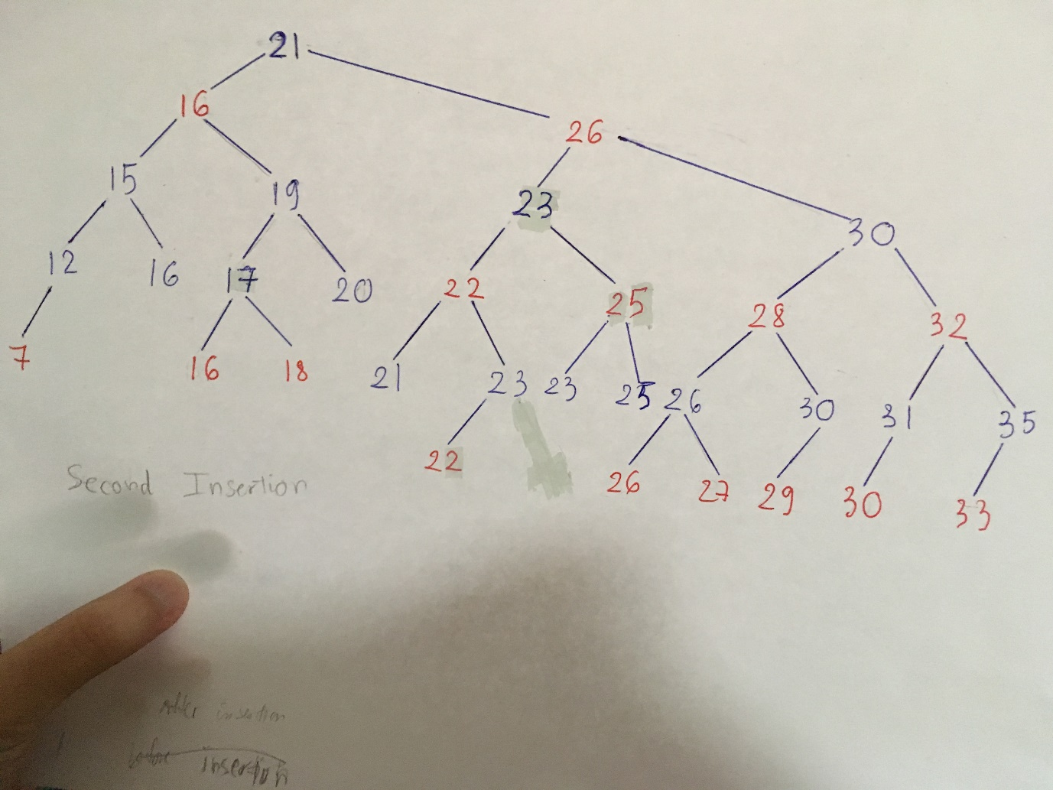

The hand-drawn result is the same as the result on the console, so the new URL is being inserted properly and all the functions are working correctly.

Next, I will try to test case 3 of insertion: the newly added node is a red left child, its parent is red, and its uncle is black. To do so, I will add an URL with a total score of 6 to the tree:

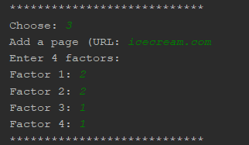

Sorted search result:

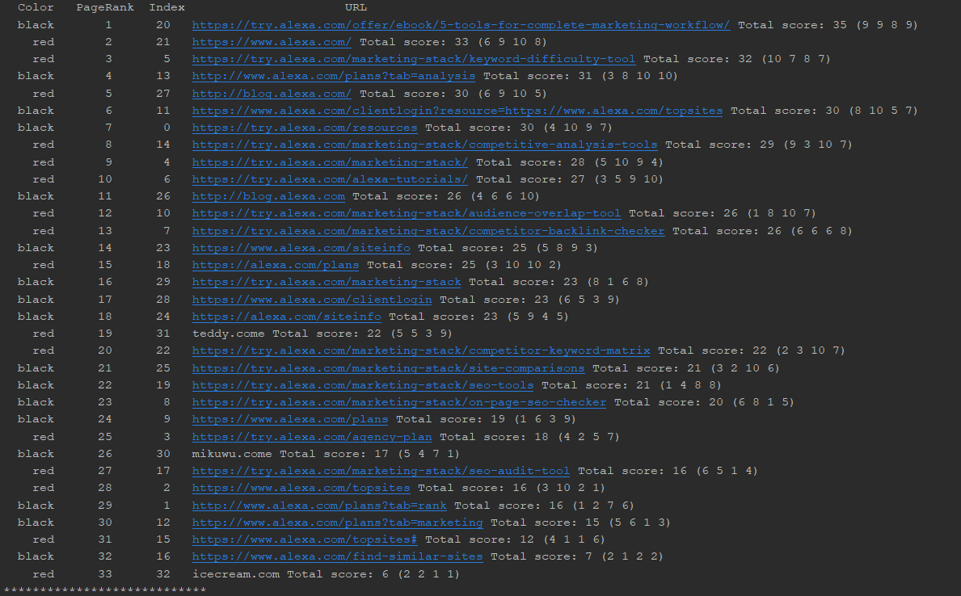

The URL with total score if 6 is successfully added and it has a color of red.

Let’s check the hand-drawn tree to see if the colors and the nodes are correct:

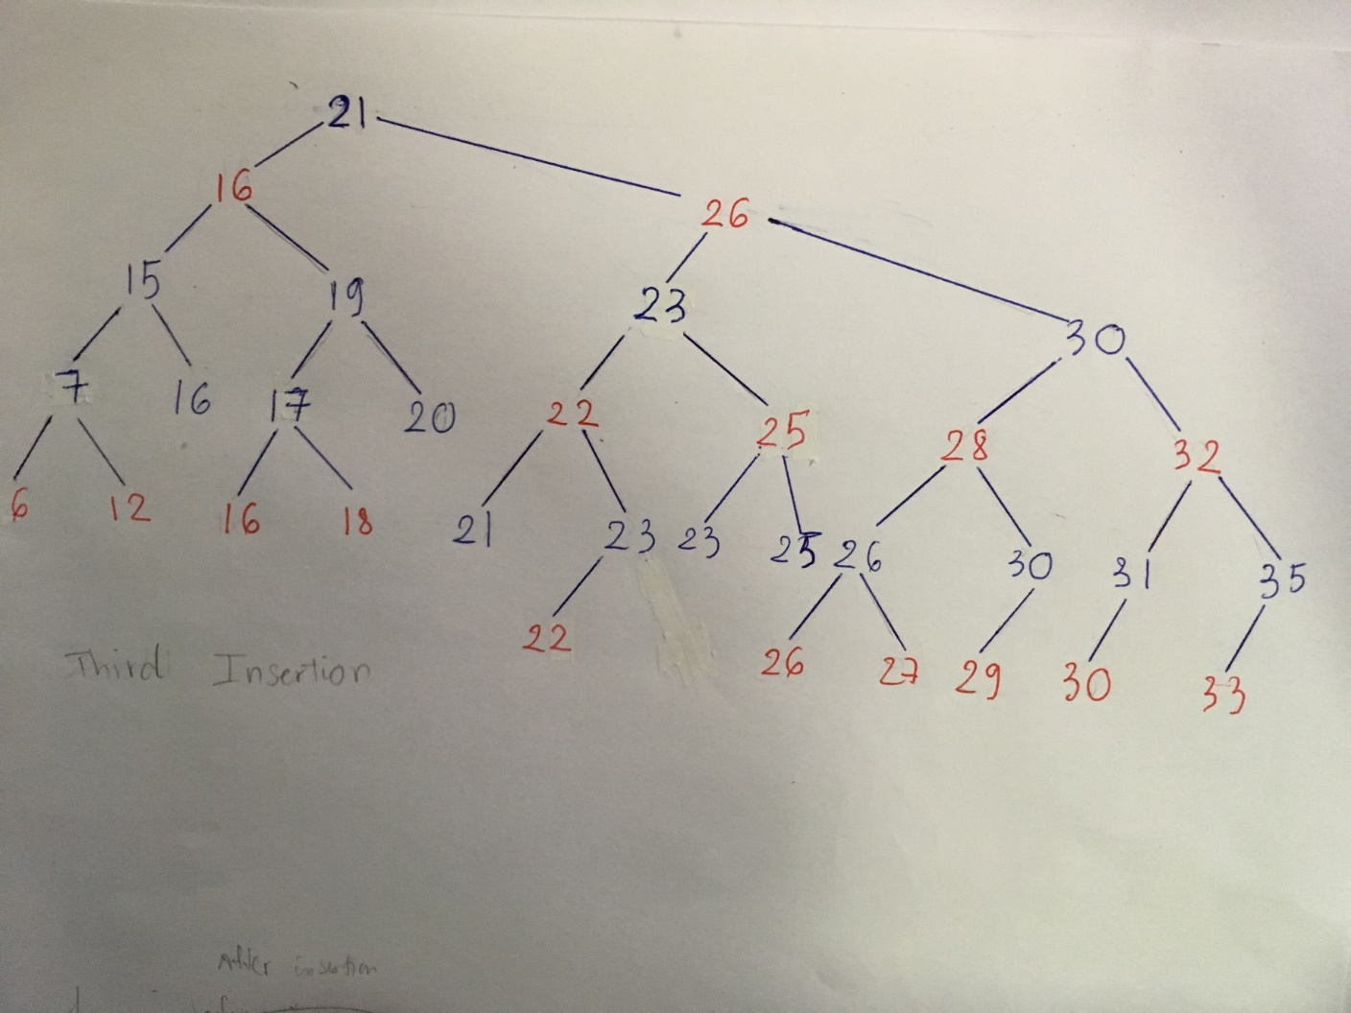

It’s correct!

# Test Case 4

In this test case, I will test RB_Delete method, which also includes RB_Delete_Fixup, RB_Transplant, Left_Rotate, and Right_Rotate methods. I will continue from the results I got from the third insertion in Test Case 3.

Case 3 of deletion: x’s sibling w is red, w’s children are black. To do this, I will add an URL with a total score of 14 in order for the tree to recolor, then delete 14 to get case 1 scenario:

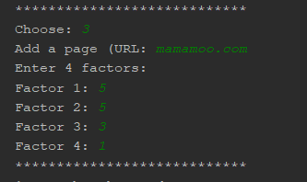

Delete URL with total score of 14:

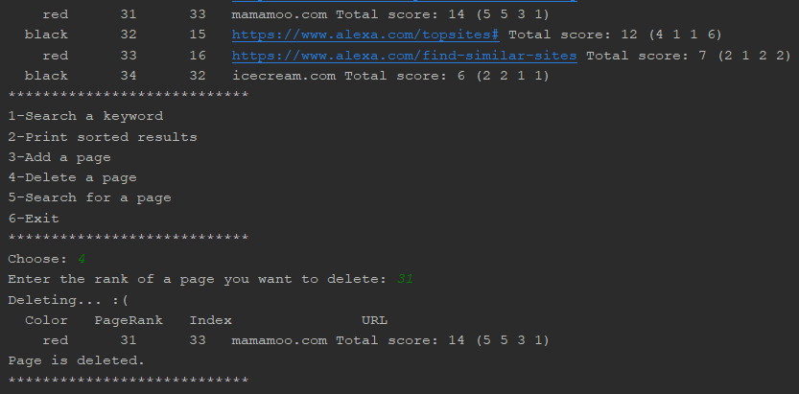

Sorted result:

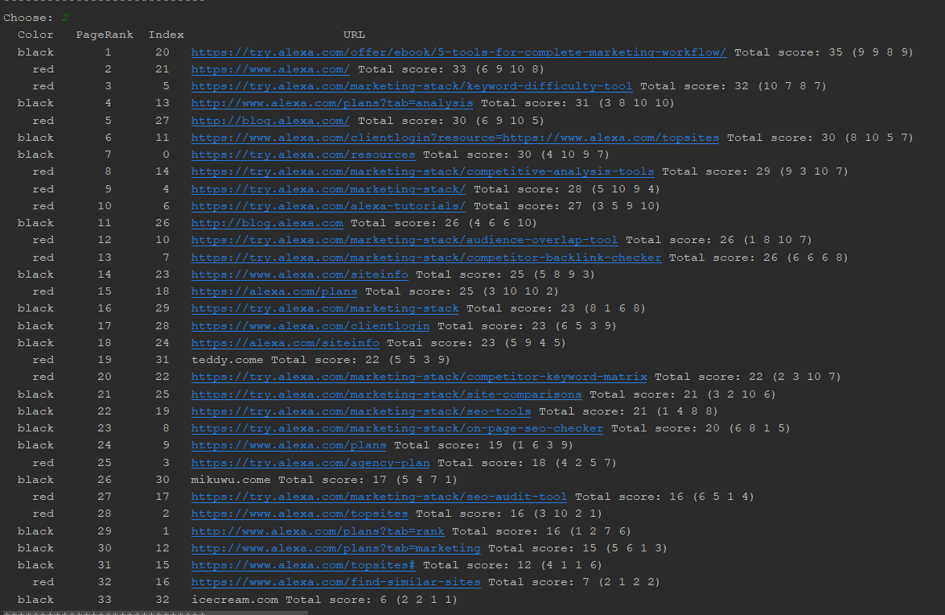

It is the same as the hand-drawn tree:

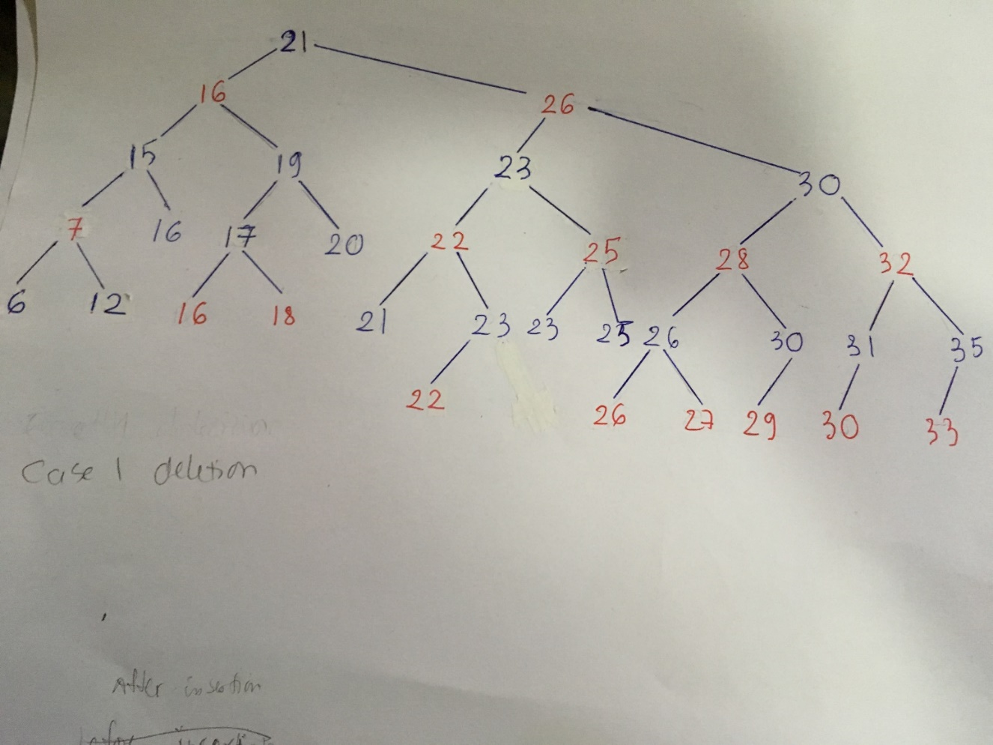

After that, I will delete the URL with total score of 16, and a PageRank of 29:

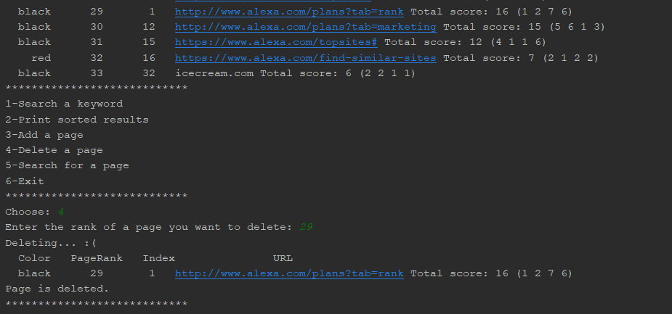

Sorted result:

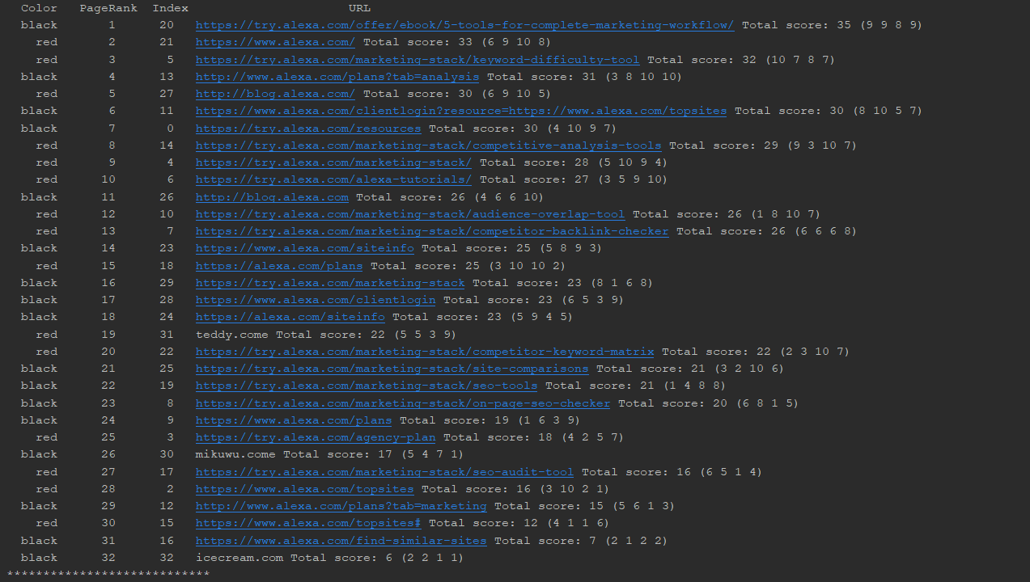

The result is the same as the hand-drawn tree:

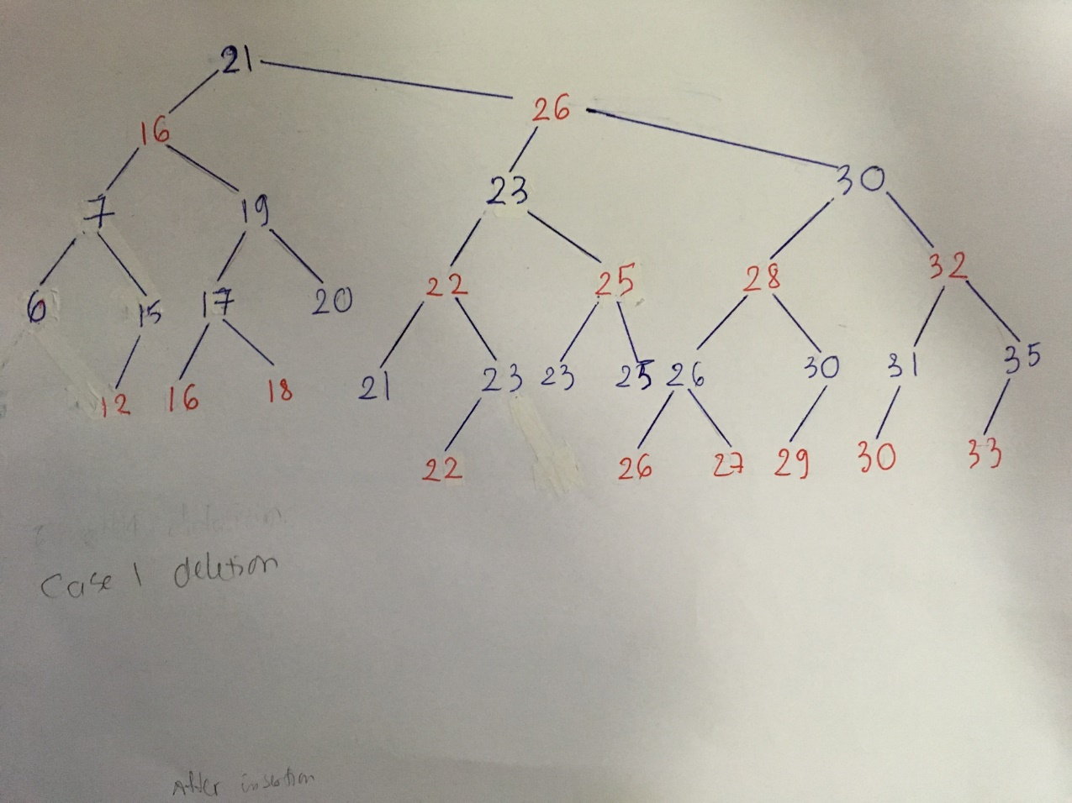

**Case 3 deletion**: x’s sibling w is black, w’s left child is red.

To do this, I just need to remove the URL with total score of 6 and a PageRank of 32:

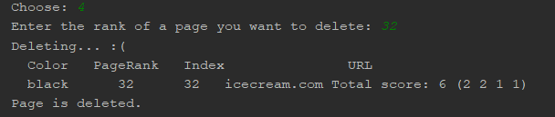

Sorted result:

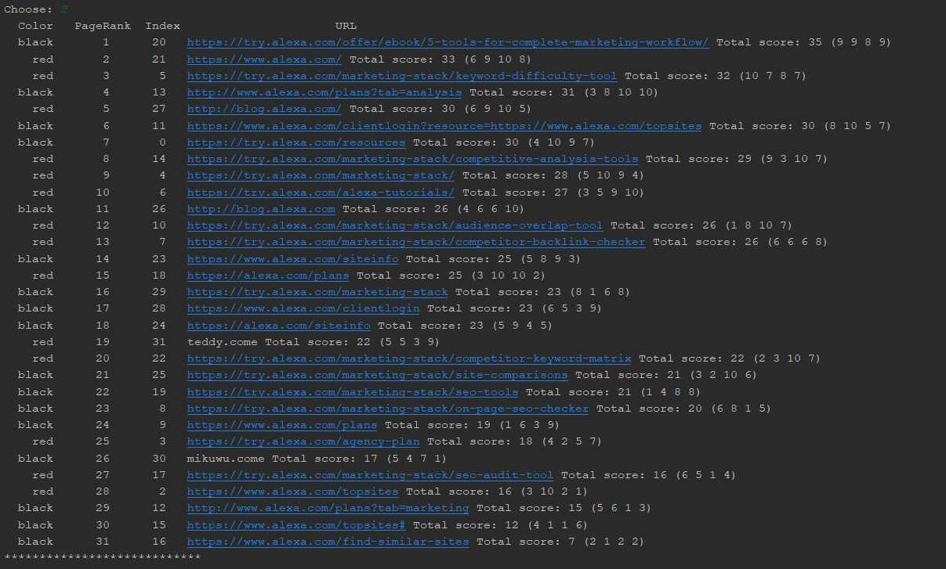

The result is the same as the hand-drawn tree:

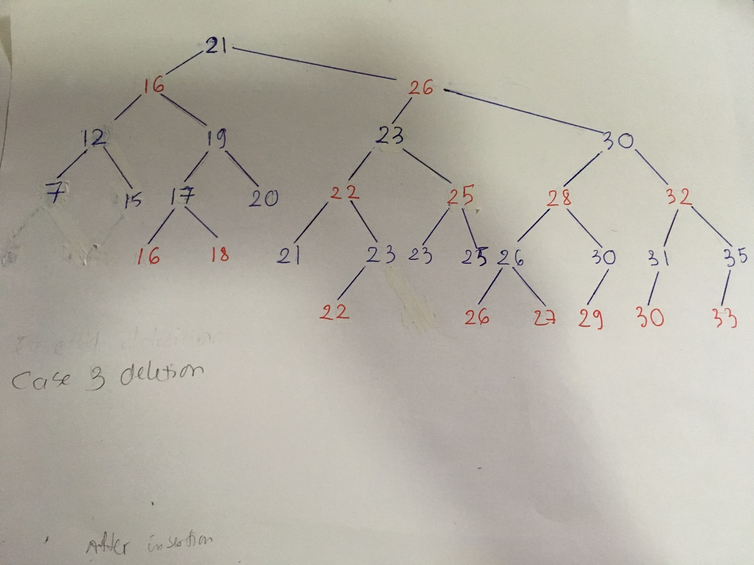

**Case 2 deletion**: x’s sibling w is black and both w’s children are black.

To do this, I will simply remove the URL with the total score of 7 and a PageRank of 31:

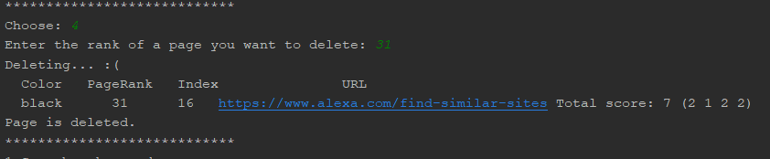

Sorted search result:

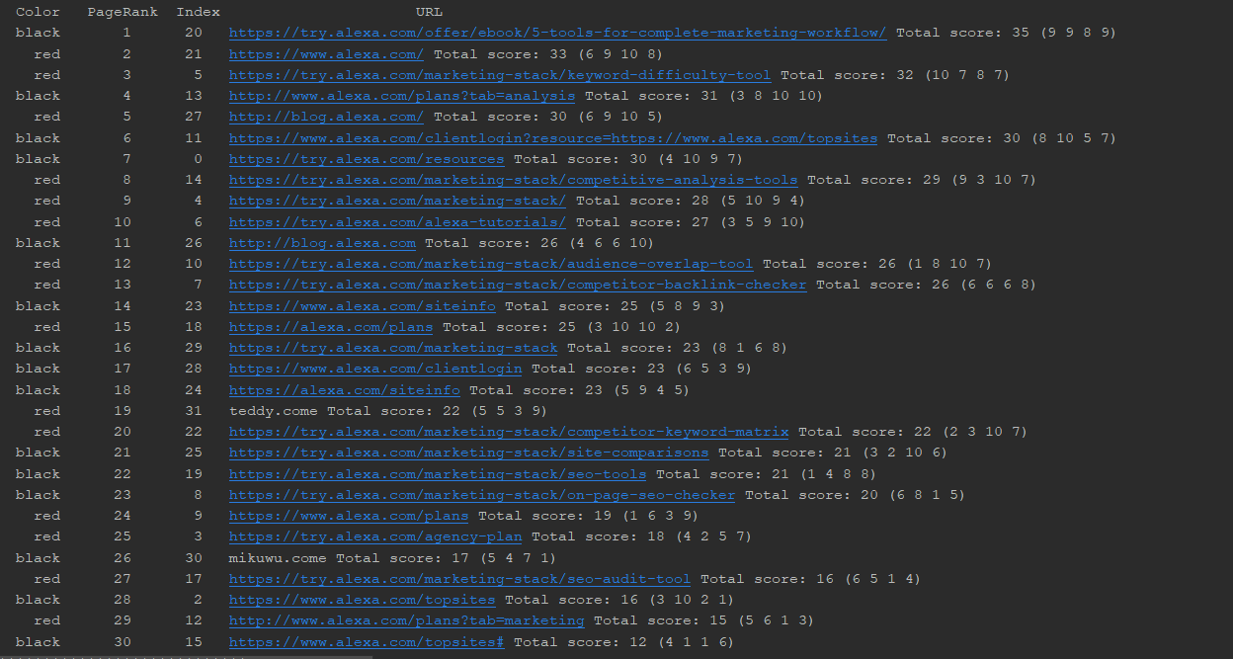

The result is exactly the same as the hand-drawn tree:

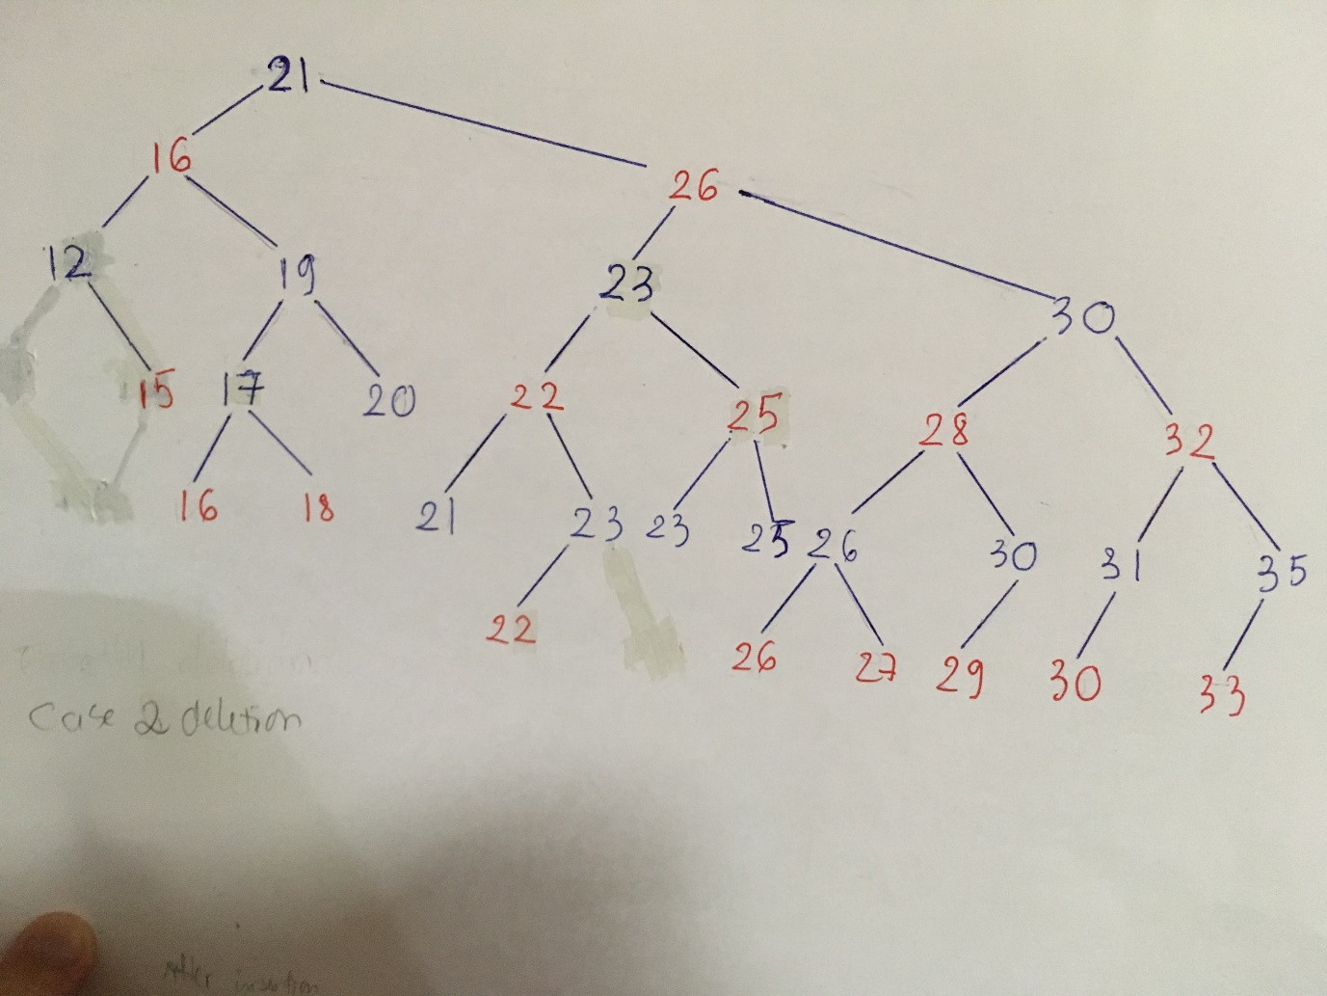

**Case 4 deletion**: x’s sibling w is black and w’s right child is red.

To get the scenario for case 4, I will delete the URL with a total score of 17, and a PageRank of 26:

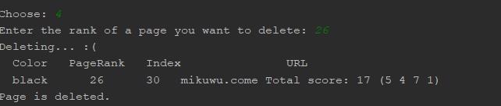

Sorted result:

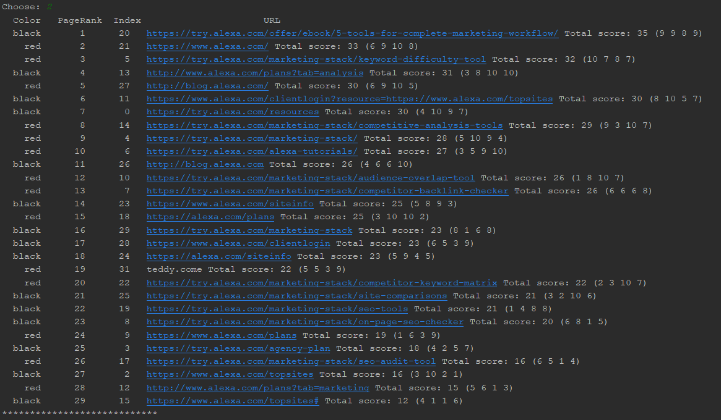

I will also delete 17 in the hand-drawn tree:

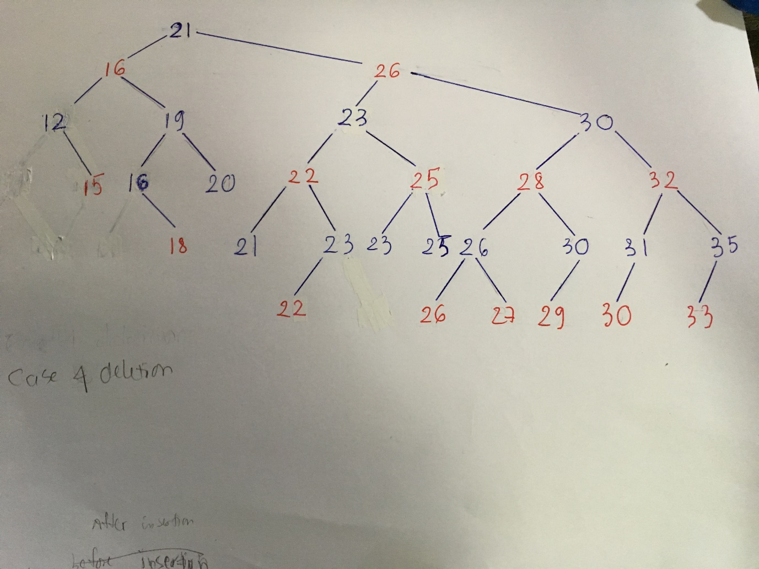

Now, for case 4, let’s delete the URL with a total score of 20, and a PageRank of 23:

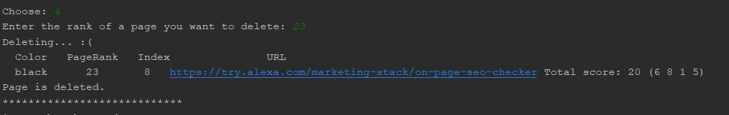

Sorted result:

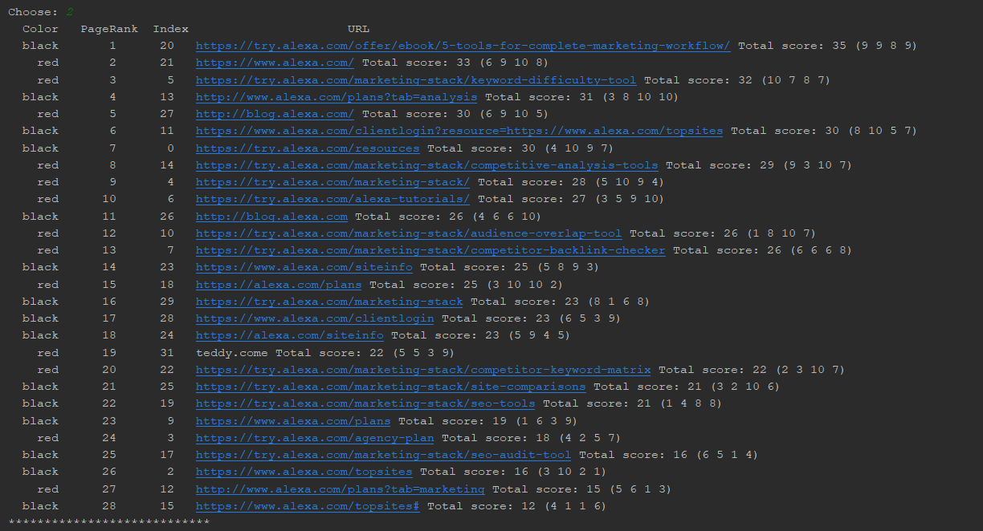

The result is exactly the same as the hand-drawn tree:

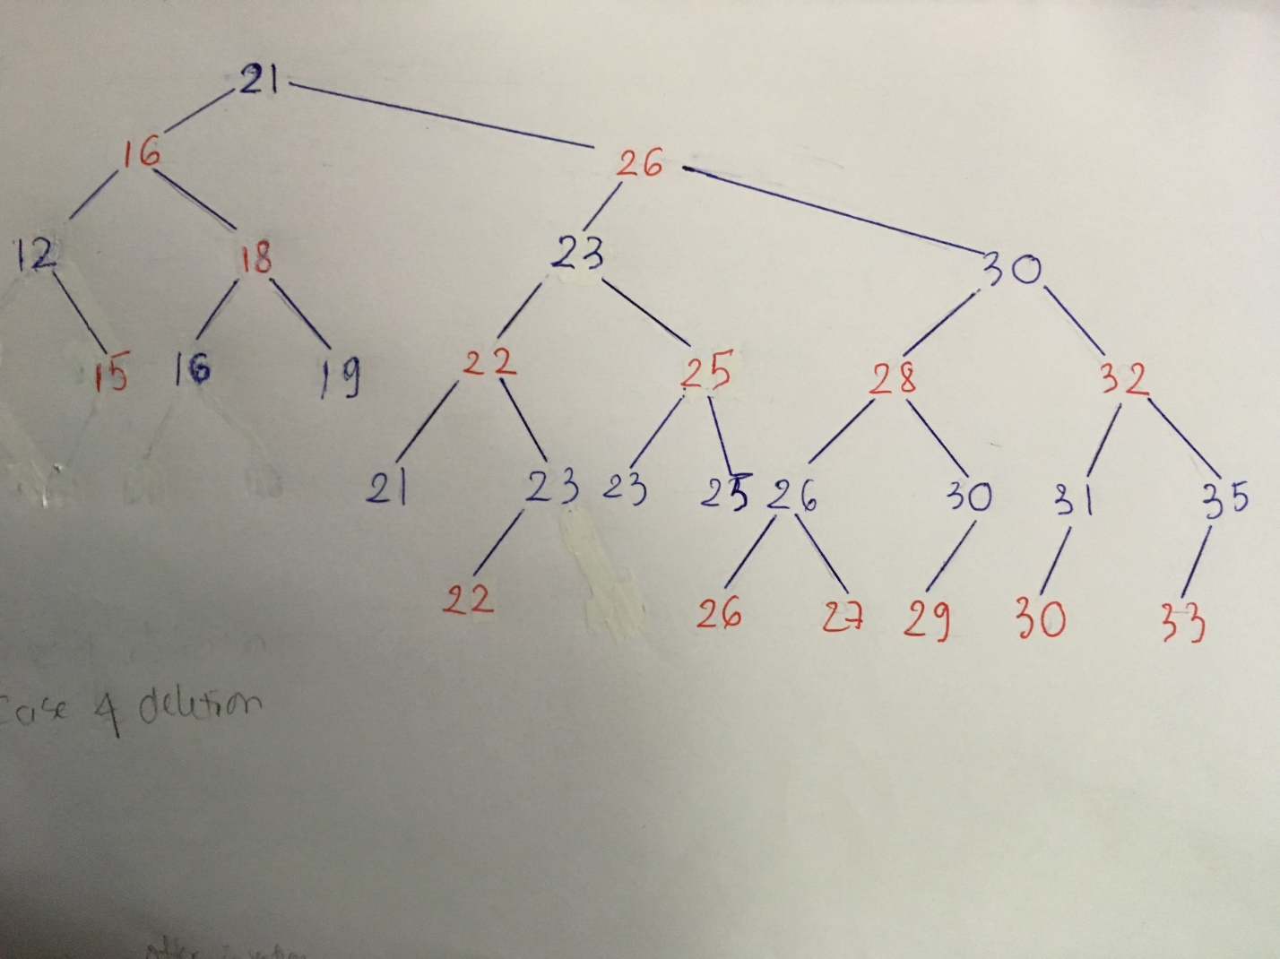

# Test Case 5

Exit the program:

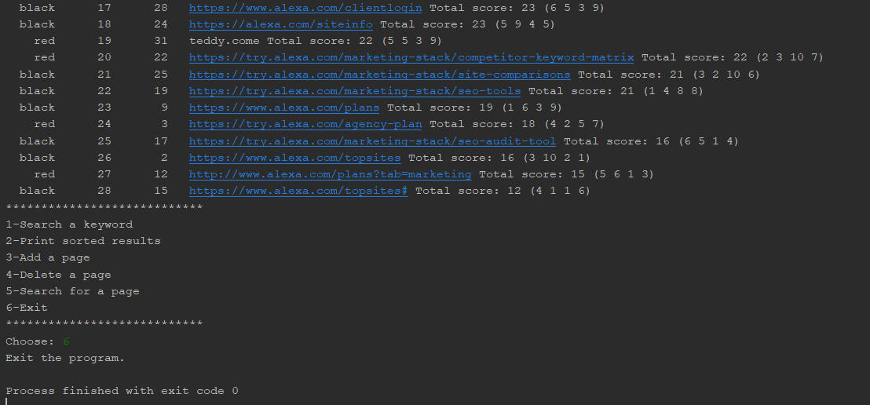

**Problem Encountered:**

I have a lot of troubles trying to design the data structure for the Red-Black Tree. Although I got the pseudo code right, the tree was messed up and the colors were not right because I was confused about the root and nil of the Tree. I tried to read the book several times and finally got everything right. After that, everything went really smooth.

**Lessons Learned:**

Overall, I got to learn about how Red-Black Tree works and I also got to learn to design my data structure better. I figured out that If I do not understand what I am doing, then I will get anything to work.